Name: ____________________
FINGERPRINTS
Please use the following numbered scale to indicate your confidence in your knowledge of topics in Unit 2: Evidence.
4 | I understand the material so well I can teach it to others
3 | I feel confident I fully understand the material
2 | I get the idea, but I feel there is more to learn
1 | This is a totally new concept for me

 | PRE DATE: _____ | POST DATE: _____
I am able to describe the rules of search and seizure (Mincey vs. Arizona, search warrants, Miranda rights).
I am able to discuss the different types of prints that can be used to identify an individual (finger, lip, foot).
I am able to trace the development of prints in a human.

I am able to describe the types of fingerprints found (latent, plastic, visible).
I am able to describe the reasons and importance of fingerprint databases.
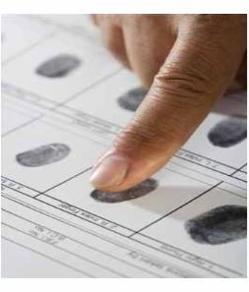
- How are prints recorded?

- How are prints lifted?

- What is in a print besides a pattern?

- What are the two skin layers? Which has the print pattern?
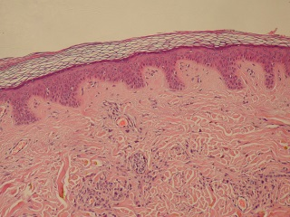
- When is a finger print formed?

- Who are the West twins? Why is their case significant?

- What is the AFIS?

- Identify the following print patterns.

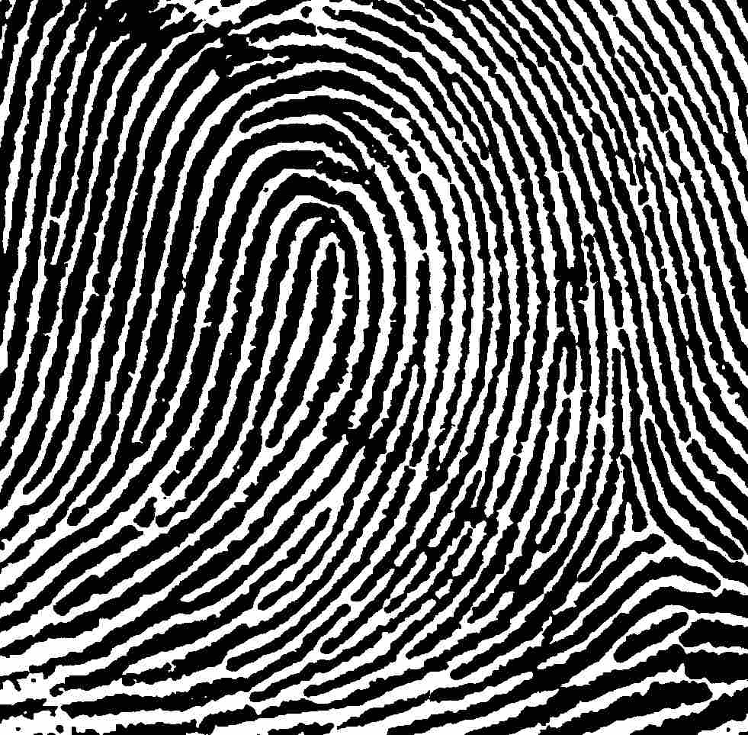
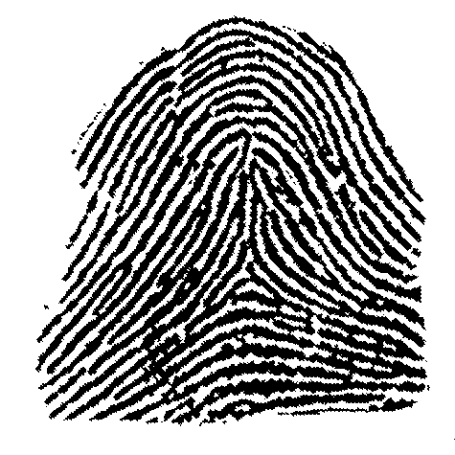
- Identify and describe each of the following ridges:
  - Plain arch
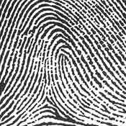
  - Tented arch

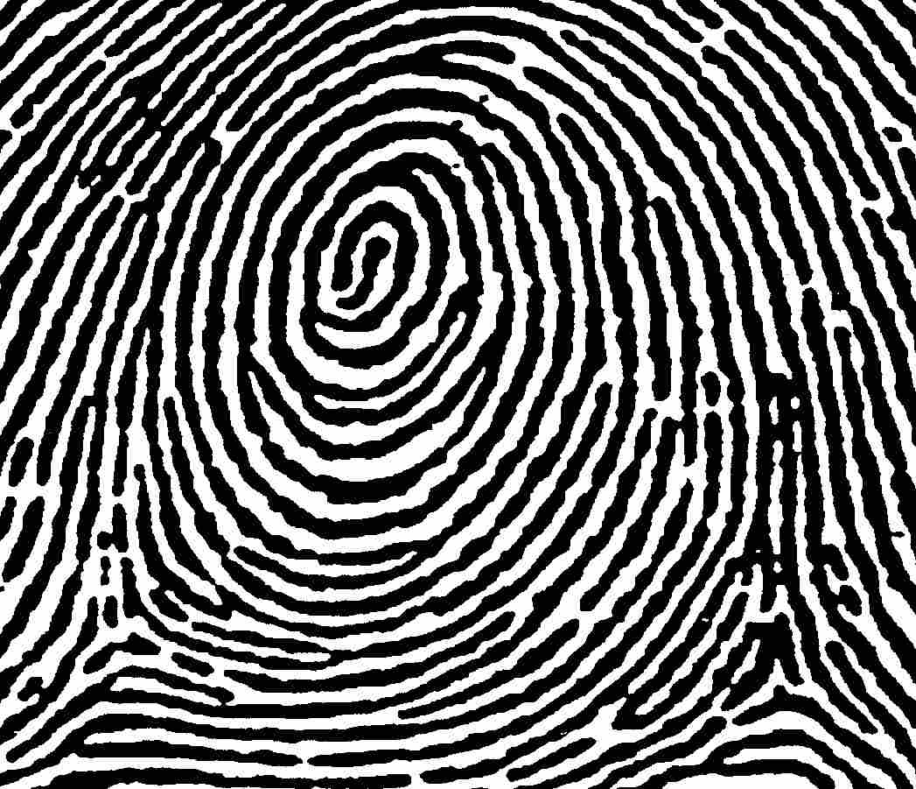
  - Radial loop
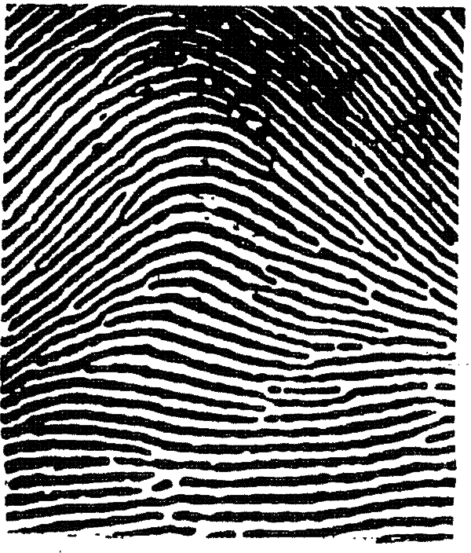
  - Ulnar loop

  - Whorl

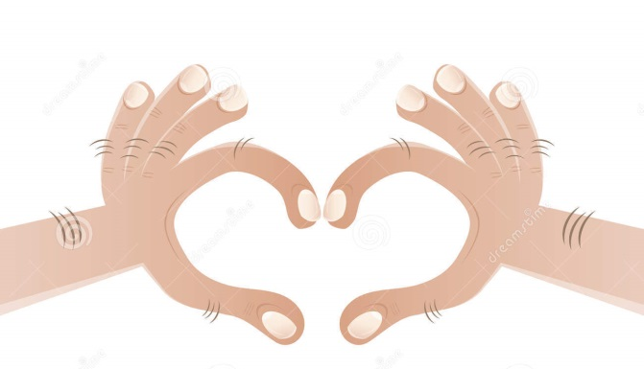
- Number the different fingers appropriately.

- What is the Henry Classification System? How is it used?

- How is statistics used in fingerprinting?

- What is a latent print?

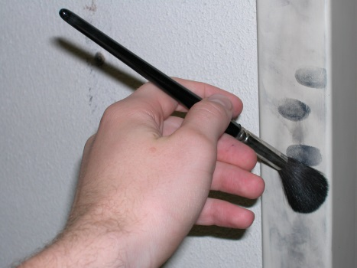
- How are latent prints collected?

- What is used to develop latent prints?

- What other prints can be collected besides fingerprints?

- What materials can prints be collected on/in?

- How is AFIS different from IAFIS?

- What is Biometrics?

