FWHS GARDEN CLUB BULB FUNDAISER
The Fairfield Warde Garden Club is a student run club that works to maintain the vegetable gardens at FWHS. We design and plant the garden boxes in the Townsend courtyard and sometimes venture out to other areas of the school. The money we raise we use to buy seeds, materials, and equipment for the garden.

Tulips and Daffodils are The Art & Soul of Spring.
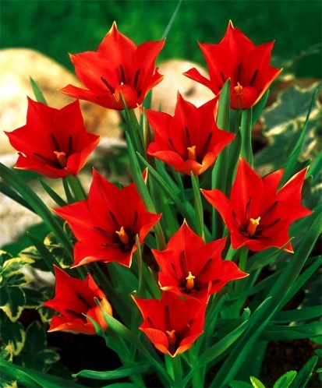
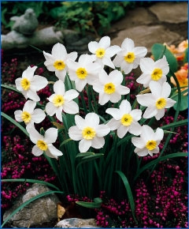
DAFFODIL: Narcissus Segovia
This precious 1962 bloom has a slightly reflexed, bright white base and a saucy, disk-shaped cup of brilliant to light greenish-yellow. The long "neck" of this flower makes it a distinctive variety. Bulb size: 10/12 cm. April. 5" to 6". HZ: 4-8.
These daffodils are DEER RESISTANT!
Cost is $9 per dozen

TULIP: Tulip linifolia
Circa 1884, this beauty has brilliant scarlet-red flowers with a jet black base, gray-purple anthers and red-edged foliage. A unique tulip! Bulb size: 5 to 6 cm. May. 6". HZ: 4-8.
These tulips are NOT deer resistant!
Cost is $7 per dozen

Please email jracioppo@fairfieldschools.org with any questions or orders.
Delivery will be early November.
Receipt of payment
Quanitity Cost
Tulips $7/12 ________ x $7 ________
Daffodils $9/12 ________ x $9 ________
Total paid ________

--------------------------Please cut here return to Mrs. Racioppo at T36 by October 23rd-----------------------------------
Name: _______________________________
Delivery Location: ______________________________ or Donation _____
Quanitity Cost
Tulips $7/12 ________ x $7 ________
Daffodils $9/12 ________ x $9 ________
Total paid ________

Please make check to FWHS Garden

Sold by: ______________________________ HR_____

