Child Development – Fall 2014
Chapter 4.1 Notes Guide

Fertilization:
_________________________________________________________________
Also called: _____________________________________________
Occurs in the: ___________________________________________
Germinal stage: _________________________________________
Zygote: ________________________________________________
Cell division: ____________________________________________
Implantation: ______________________________________________________
__________________________________________________________________
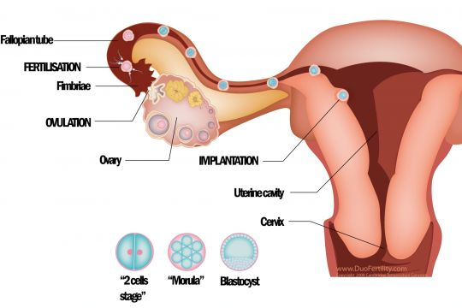

Embryonic stage
Embryo: ________________________________________________________
_______________________________________________________________
Amniotic sac: ____________________________________________________
_______________________________________________________________
Amniotic fluid: ___________________________________________________
Placenta: ________________________________________________________
________________________________________________________________
Umbilical cord: ___________________________________________________
________________________________________________________________

Fetal stage: ______________________________________________________
________________________________________________________________
1. ______________________________________________________________
2. ______________________________________________________________
3. ______________________________________________________________
4. ______________________________________________________________

Preparing for birth
1. ______________________________________________________________
2. ______________________________________________________________

