Child Development Fall 2014
Chapter 4.2 Notes Guide
A Closer Look at Conception
Genetics
Heredity: _________________________________________________________
Chromosomes: _____________________________________________________
__________________________________________________________________
Gene: _____________________________________________________________
__________________________________________________________________
__________________________________________________________________
DNA: ______________________________________________________________
___________________________________________________________________
Dominant & Recessive Genes
___________________________________________________________________
___________________________________________________________________
___________________________________________________________________

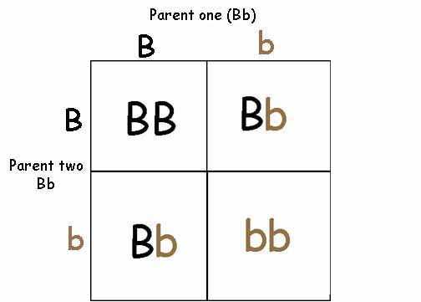

Co-dominant inheritance: _____________________________________________
___________________________________________________________________
MOM DAD CHILD
A & B are co-dominant. A A AA = A
O is recessive A B AB = AB
A O AO = A
B B BB = B
B O BO = B
B A BA = AB
O O OO = O

Polygenetic: ________________________________________________________
Examples: ______________________
______________________
______________________
Why are we unique?
___________________________________________________________________
___________________________________________________________________
Gender: ____________________________________________________________
Girl: _________________________________________________________
Boy: _________________________________________________________
Multiple Births
Fraternal Twins: _____________________________________________________
___________________________________________________________________
Chances: ______________________________________________________
Identical Twins: _____________________________________________________
__________________________________________________________________
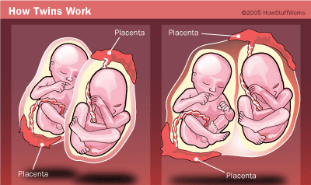

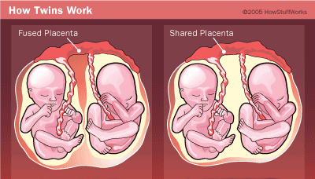

Conjoined Twins: ____________________________________________________
Chances: ______________________________________________________
Family Planning
1. _________________________________________________________________
2. _________________________________________________________________
3. _________________________________________________________________
4. _________________________________________________________________
Infertility
___________________________________________________________________
___________________________________________________________________
Male: _________________
Female: _______________
Unknown/Both: _______________
Options for infertile couples:
1. ________________________________
2. ________________________________
3. ________________________________
4. ________________________________
5. ________________________________

