Child Development – Fall 2014
Chapter 4.4 Notes Guide
Avoiding Dangers to the Baby
Alcohol and Pregnancy
Fetal Alcohol Syndrome (FAS):
1. _______________________________________________________________
2. _______________________________________________________________
3. _______________________________________________________________
Facial Characteristics:
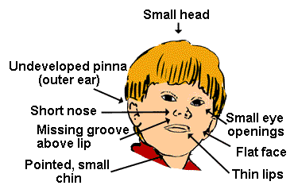

Other Characteristics:
1. __________________________________________________________
2. __________________________________________________________
3. __________________________________________________________
4. ____________________________________________________________
5. ____________________________________________________________
6. ____________________________________________________________

Fetal Alcohol Effects (FAE):
1. _____________________________________________________________
2. Severity depends on:
a. ________________________________________________________
b. ________________________________________________________
c. ________________________________________________________

Other Drugs
Medicines: ______________________________________________________
1. _________________________________________________________
2. _________________________________________________________
3. _________________________________________________________

Caffeine: _________________________________________________________
1. __________________________________________________________
2. __________________________________________________________
3. __________________________________________________________

Tobacco (nicotine):
1. ________________________________________________________________
2. ________________________________________________________________

Illegal Drugs: ________________________________________________________
1. _________________________________________________________________
2. _________________________________________________________________
3. _________________________________________________________________
4. _________________________________________________________________

X-rays: _____________________________________________________________
___________________________________________________________________

Hazardous Substances and Chemicals:
1. ____________________________
2. ____________________________
3. ____________________________
4. ____________________________
5. ____________________________
6. ____________________________

Infections:
1. _______________________________________________________________
a. __________________________________________________________
2. _______________________________________________________________
a. __________________________________________________________
b. __________________________________________________________
c. __________________________________________________________

Sexually Transmitted Infections (STI’s):
1. _______________________________________________________________
2. _______________________________________________________________
3. _______________________________________________________________
a. ____________________________
b. ____________________________
c. ____________________________

