Child Development – 2014-15

Chapter 7.1 Notes Guide

Infant Growth and Development

Growth: _________________________________________________

Growth during the first year:
Growth charts: ____________________________________________
________________________________________________________
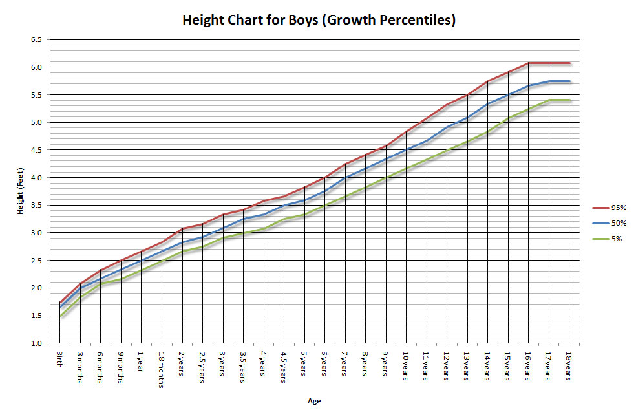

Weight:
1. ______________________________________________________
2. ______________________________________________________

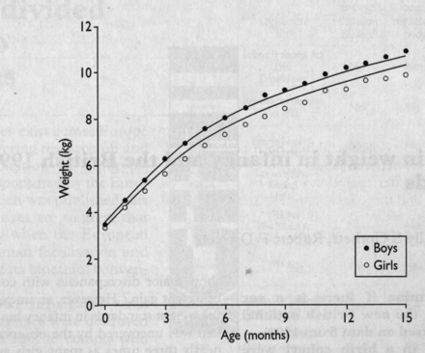

Length:
1. ______________________________________________________

Body shape:
1. _________________________________________________________
2. _________________________________________________________
3. _________________________________________________________
Proportion:
1. _________________________________________________________
2. _________________________________________________________
3. _________________________________________________________
Development:
___________________________________________________________
___________________________________________________________
3 Patterns of Physical Development:
1. __________________________________________
a. ____________________________________________________
ex. ___________________________________________________
___________________________________________________
2. __________________________________________
a. ____________________________________________________
ex. ___________________________________________________
3. __________________________________________
a. ____________________________________________________
ex. ___________________________________________________

Gross motor skills:
________________________________________________________
__________________________________________________________
1. ________________________________________________________

Fine motor skills: ________________________________________________________
__________________________________________________________

Hand-eye coordination:
________________________________________________________
__________________________________________________________
Reflexes: __________________________________________________
1. ________________________________________________________
2. ________________________________________________________
3. ________________________________________________________
4. ________________________________________________________

Developmental Milestones:
__________________________________________________________
__________________________________________________________

Influences on Growth and Development:

Nature AND Nurture play a significant role in a child’s development!

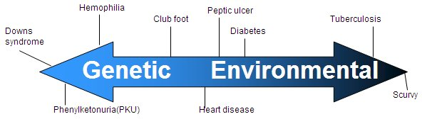

Heredity: __________________________________________________
1. __________________________________________
2. __________________________________________
3. __________________________________________

Nutrition: __________________________________________________
Can affect: ___________________________________
___________________________________
___________________________________
___________________________________
___________________________________

Health:
1. ________________________________________________________
__________________________________________________________
2. ________________________________________________________
__________________________________________________________

Brain Development During the First Year

Experiences:
___________________________________________________________
a. _____________________________________________________
_____________________________________________________

Environment:
Stimulating Environment: ______________________________________
___________________________________________________________
1. _______________________________
2. _______________________________
3. _______________________________
4. _______________________________
5. _______________________________

Vision:
1. ________________________________________________
2. ________________________________________________
3. ________________________________________________
4. ________________________________________________

Depth Perception:
__________________________________________________________
__________________________________________________________

Hearing:
1. ________________________________________________________
2. ________________________________________________________
3. ________________________________________________________

Touch:
1. ________________________________________________________
2. ________________________________________________________
3. ________________________________________________________

Smell and Taste:
1. __________________________________________________________
____________________________________________________________
2. __________________________________________________________
3. __________________________________________________________
____________________________________________________________
____________________________________________________________

Lullaby YouTube: http://www.youtube.com/watch?v=xuCMCALnis4
Argument YouTube: http://www.youtube.com/watch?v=oAFln2Ps_Ik

