FISH QUIZ REVIEW
- Label the following structures on a fish: dorsal, pectoral, anal, pelvic and caudal fins, operculum, mouth, eye and lateral line.

- Identify the function of each in a fish:
  - Dorsal

  - caudal fin

  - operculum

  - lateral line

- Describe the shapes of different fish and the adaptation that makes it successful. (fast, slow, camouflaged, bottom dweller, hides between corals, etc)
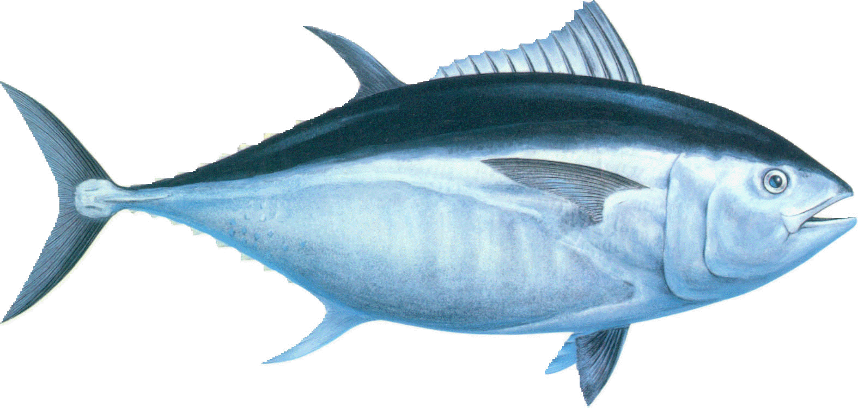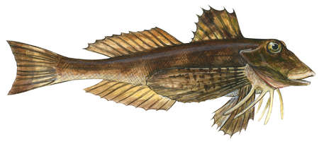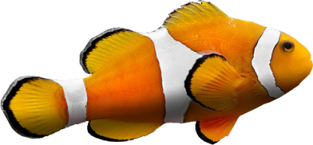

- Fish are ectotherms. What does this mean and why is it relevant to a fish?

- How does the temperature of a Caribbean fish differ from an Arctic fish?

- Describe what might occur if a salt water fish was put in fresh water. How and which direction would the water move?

- Describe what might occur if a fresh water fish was put in salt water. How and which direction would the water move?

- How do some fish migrate between fresh and salt water and regulate their water concentrations?

- What must the fish do if they migrate from salt to fresh water?

- What must the fish do if they migrate from fresh to salt water?

- Describe the relative number of eggs a fish produces. Discuss survival and mortality rate.

- When fish fry (baby fish) have a higher survival rate, does the fish species tend to have more or few eggs? Explain.

- What is the purpose of gill/gill rakers in bony fish?

b
FISH QUIZ REVIEW
- Label the following structures on a fish: dorsal, pectoral, anal, pelvic and caudal fins, operculum, mouth, eye and lateral line.

- Identify the function of each in a fish:
  - Dorsal

  - caudal fin

  - operculum

  - lateral line

- Describe the shapes of different fish and the adaptation that makes it successful. (fast, slow, camouflaged, bottom dweller, hides between corals, etc)

- Fish are ectotherms, they do not regulate their internal body temperature. What does this mean and why is it relevant to a fish?

- How does the temperature of a Caribbean fish differ from an Arctic fish?

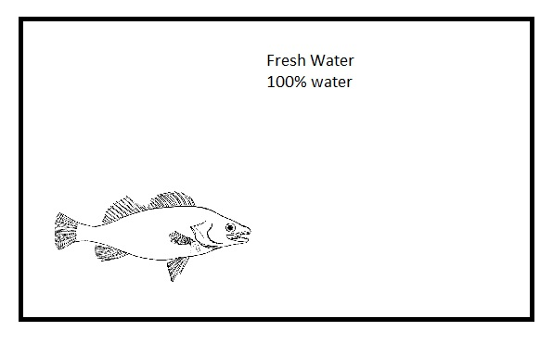

- Describe what might occur if a salt water fish was put in fresh water. How and which direction would the water move?

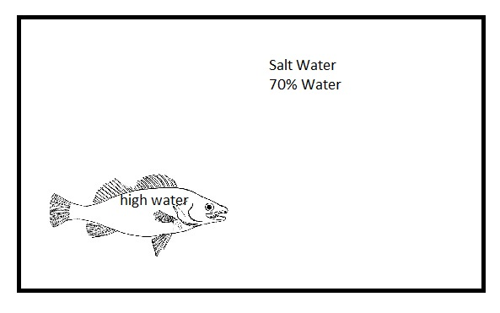

- Describe what might occur if a fresh water fish was put in salt water. How and which direction would the water move?

- What must the fish do if they migrate from salt to fresh water?
Pump water in or out? Why?

- What must the fish do if they migrate from fresh to salt water?
Pump water in or out? Why?

- Why do fish lay so many eggs? What happens to the majority of them?

- When fish fry (baby fish) have a higher survival rate, does the fish species tend to have more or few eggs? Explain.

- What is the purpose of gill/gill rakers in bony fish?

- What is protecting the gills in a bony fish?

c
FISH QUIZ REVIEW
- Label the following structures on a fish: dorsal (top), pectoral(chest), anal (bottom back), pelvic (bottom middle) and caudal (tail fin) fins, operculum (gill covering), mouth, eye and lateral line.

- Identify the function of each in a fish:
  - Dorsal (top)

  - caudal fin (tail)

  - operculum (gill covering)

- Describe the shapes of different fish and the adaptation that makes it successful. (fast, slow, camouflaged, bottom dweller, hides between corals, etc)

- If the temperature of the water is 37 degrees, what is the internal temperature of the fish?
  - Same as the water
  - Warmer, a fish creates their own heat
  - Colder, a fish cools their cells

- Describe what might occur if a salt water fish was put in fresh water. How and which direction would the water move? (circle one)
Water moves in
Water moves out

- Describe what might occur if a fresh water fish was put in salt water. How and which direction would the water move? (circle one)
Water moves in
Water moves out

- What must the fish do if they migrate from salt to fresh water as water rushes into their cells? (circle one)
Increase urination (release more water)
Decrease urination (hang on to more water)

- What must the fish do if they migrate from fresh to salt water as water leaves their cells? (circle one)
Increase urination (release more water)
Decrease urination (hang on to more water)

- How many eggs do most fish have? (circle one)
1, 10, 100 or 10000

- What happens to most of the eggs that are laid?
  - They all die
  - They all survive
  - Many get eaten

- What is the purpose of gill in bony fish?
  - They are used to swim
  - They are used to eat prey
  - They are used to get oxygen

