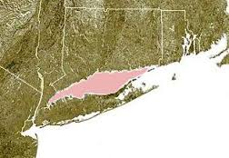
LONG ISLAND SOUND & MARINE STUDIES

Please use the following numbered scale to indicate your confidence in your knowledge of topics in LONG ISLAND SOUND AND MARINE STUDIES.

4 | I understand the material so well I can teach it to others
3 | I feel confident I fully understand the material
2 | I get the idea, but I feel there is more to learn
1 | This is a totally new concept for me

Curriculum Objective | Pre Date: _____ | Post Date: ____
I am able to describe how Long Island Sound was created.
I am able to Describe the general characteristics of an estuary, and state why Long Island Sound is an estuary.
I am able to Recognize the intertidal zone is in constant flux.

I am able to Evaluate marine organism adaptations to Salinity changes living in this zone
I am able to Evaluate marine organism adaptations to Temperature changes living in this zone
I am able to Evaluate marine organism adaptations to Desiccation living in this zone
I am able to Identify the role of biotic and abiotic factors that provide favorable conditions for survival in an intertidal community.
I am able to Identify and describe physical factors that affect marine organisms: salinity, dissolved gases, space, turbidity, phosphates, nitrates, pressure, pH, water, exposure to air, substrate, light availability, waves, currents, tide, temperature, pollutants, ice, and minerals.
I am able to Identify the following pieces of laboratory or field equipment used to measure water quality and other abiotic factors, and sample biotic factors: dissolved oxygen meter, thermometer, secchi disk, salinometer, (Hydrometer); microscopes, meter stick, plankton net, seine net, dip net
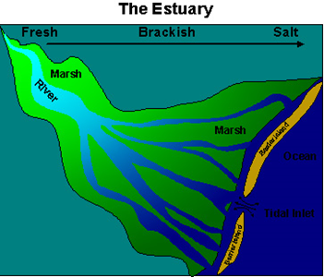

- Describe how Long Island Sound was formed.

- What is an estuary?

- What does the change in tides bring with it?

- What types of critters enjoy an estuary?

- Determine the location where fresh and salt water enter the Sound.

- What are the 3 major rivers in LIS?

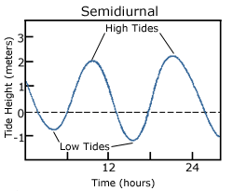
- How many tides does LIS have each day? What is it called?

- Approximately how many people live around LIS?

- What are some of the economic values of LIS?

- What are some of the ecological values of LIS?

- What is the temperature range of LIS? Why does it change?

- What is the salinity range of LIS? Why does it change?

- Average depth of LIS ______ Ocean ______ Deepest point ______

- LIS is ______ miles wide, ______ miles long. It has ______ miles of coastline.

