LIS JOURNAL ENTRY
Complete the map on the back page and glue into your journal prior to the localized Fairfield maps.(10 pts)
Identify the main characteristics of Long Island Sound and place in your journal AFTER the Fairfield maps(3 pts)
Temperature Range:
Salinity:
Dissolved oxygen level needed for fish:

Create a chart in your journal similar to this one to complete each time we visit the field (7 pts)
Date | Measurement | Average or Range
Temperature
Salinity
Dissolved Oxygen
Nitrates
Turbidity
Habitat
(salt marsh, mud flats, rocky, fouling
Organisms found

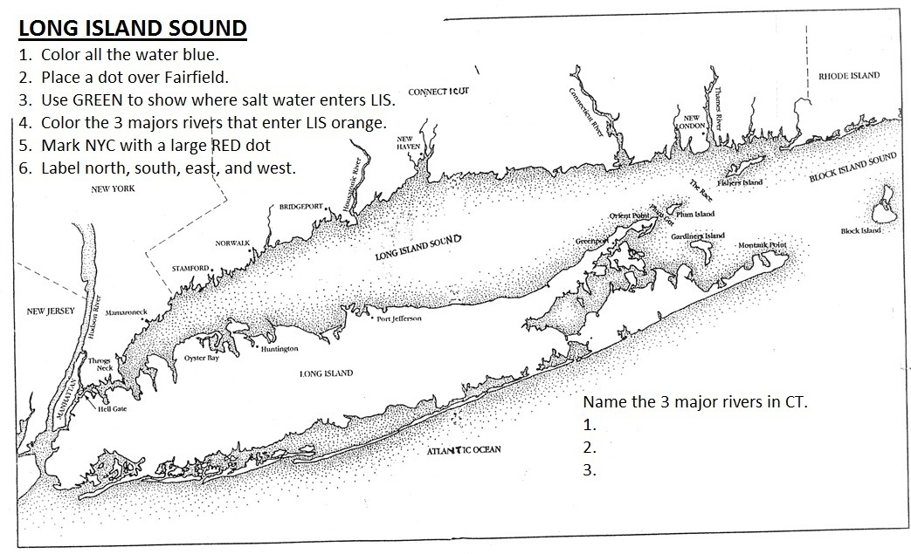

LIS Journal Entry Rubric POINT VALUE
All maps in proper location 10 _____
the main characteristics LIS 3 _____
temp, salt DO
Field Trip Chart w/units 7 _____
LIS Map
Blue water 1 _____
Fairfield Dot 1 _____
Salt water Green 2 _____
3 Rivers 3 _____
NYC red Dot 1 _____
N, S, E, W 1 _____

LIS Journal Entry Rubric POINT VALUE
All maps in proper location 10 _____
the main characteristics LIS 3 _____
temp, salt DO
Field Trip Chart w/units 7 _____
LIS Map
Blue water 1 _____
Fairfield Dot 1 _____
Salt water Green 2 _____
3 Rivers 3 _____
NYC red Dot 1 _____
N, S, E, W 1 _____

