Long Island Sound and MARINE ECOLOGY TEST REVIEW

- Describe the function of the following tools.
  - Secchi disk
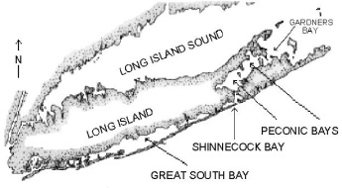
  - DO test
- Describe how Long Island Sound was created.
- Label on a map where fresh water and salt water come from into and out of LIS?
- Describe an estuary.
- Identify and describe how LIS is used economically, give 3 examples.
- Identify and describe how LIS is used ecologically, give 3 examples.
- What type of water is found in an estuary? How is it made?
- What abiotic(non-living) factors affect the organisms living in an estuary?
- Name the three rivers that feed into LIS from CT.
- How salty is LIS? What is the average temperature?
- What types of fluctuations must an organism living in LIS have to deal with?
- How many tides are in LIS?
- What controls a tide?
- How do tides affect living organisms in LIS?

- Define the following terms and give examples of each
  - Plankton
  - Nekton
  - Benthos

- What is detritus? Where does it come from?

- What is detritus used for?

- Distinguish between these types of consumers: suspension feeder, herbivore, scavenger,
filter feeder, predator, deposit feeder, opportunistic feeder, omnivore, primary, secondary, tertiary and quaternary consumers. State example(s) of each.

- Construct a simple food chain

- Turn your food chain into a food web.

- What happens to energy as you move up the food chain? Where does it go?

- How does an organism use energy and nutrients it receives from its food?

- What does an energy pyramid represent? (3 things)

- What is the rule of 10s and how does it apply to the food chain?

- Describe the difference between an autotroph and a heterotroph.

- What is the difference between photosynthesis and chemosynthesis? Where does each occur?

- Identify and describe interactions among marine organisms (biotic factors). Be sure to give an example of each.
  - Competition
  - trophic or feeding relationships;
  - producer
  - consumer
  - decomposer (recyclers).
- State the taxa in the correct order (KPCOFGS)

- Use a Dichotomous key to identify species (you can practice using this site http://www.biologycorner.com/worksheets/pamishan.html )

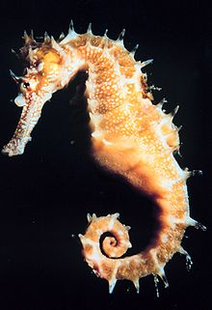
Hippocampus sp.
Scientific classification
Kingdom: | Animalia
Phylum: | Chordata
Class: | Actinopterygii
Order: | Syngnathiformes
Family: | Syngnathidae
Subfamily: | Hippocampinae
Genus: | Hippocampus
Species | breviceps

- Classify an organism to its scientific name and define its relationship to the different levels of classification. Be able to write a scientific name correctly. Write the scientific name of the sea horse at right.

- State examples and some distinguishing characteristics of each of the animal phyla:

  - Porifera
  - Cnidaria
  - Ctenophora
  - Annelida
  - Arthropoda
  - Mollusca
  - Echinodermata
  - Chordata.

