MARINE ECOLOGY Name: ____________________________
Please use the following numbered scale to indicate your confidence in your knowledge of topics in BIOCHEMISTRY.
4 | I understand the material so well I can teach it to others
3 | I feel confident I fully understand the material
2 | I get the idea, but I feel there is more to learn
1 | This is a totally new concept for me

 | PRE DATE: | POST DATE:
Students will be able to Classify an organism to its scientific name and define its relationship to the different levels of classification.
Students will be able to State examples and some distinguishing characteristics of each of the animal phyla: Porifera, Cnidaria, Ctenophora, Annelida, Arthropoda, Mollusca, Echinodermata, Chordata
Students will be able to Distinguish between solitary and colonial tunicates and identify three characteristics that place all tunicates into the phylum Chordata
Students will be able to Describe the flow of energy and nutrition through a marine ecosystem: Abiotic and biotic factors
Students will be able to Create a marine food chains and food webs and explain the flow of energy.
Students will be able to Categorize organisms according to their appropriate lifestyles (plankton, nekton, benthos)and their feeding patterns.
Students will be able to Identify and describe interactions among marine organisms (biotic factors): competition, symbiosis (commensalism, mutualism, parasitism), trophic or feeding relationships; producer, consumer, decomposer (recyclers)
Students will be able to Role of nitrogen recycling by microbes

Students will be able to Describe the general characteristics of an estuary and state why Long Island Sound is an estuary
Students will be able to Explain the importance of an estuary and in particular, LIS

FOOD CHAIN NOTES
- Write the taxa in the correct order.

- What is the scientific name of an organism?

- Correctly write the scientific name of an orca whale.
- Define the following and give examples:
  - Plankton

  - Nekton

  - Benthos

- What is a food chain?

- Label the following food chain using the terms: heterotroph, secondary consumer, autotroph, tertiary consumer, carnivore, primary consumer, omnivore, quaternary consumer, producer, herbivore

Algae - krill - herring- stripped bass - seal

- What is an autotroph?

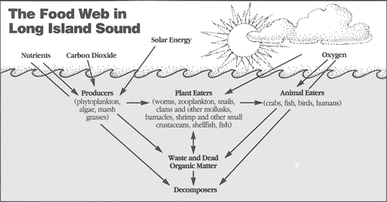

- What are they making? What process are they using to make it?

- What is a heterotroph?

- What is the difference between a carnivore, omnivore and herbivore?

- How is food chain different than food webs?

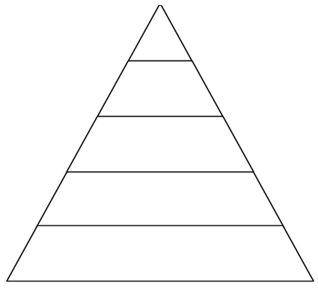
- What is a food pyramid?

- What three things does a food pyramid represent?

- Place the food chain from #3 into the pyramid at right.

- Why are things placed in the pyramid at the top or the bottom?

- What is detritus? Where does it come from?

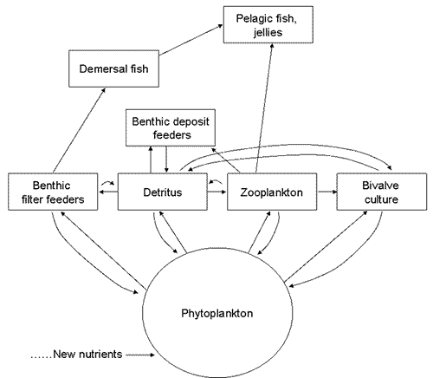
- What is a decomposer in the ocean? What does it do?

- What do decomposers do with nitrogen?

- What does bio-magnification mean and how does it relate to a food chain/web?

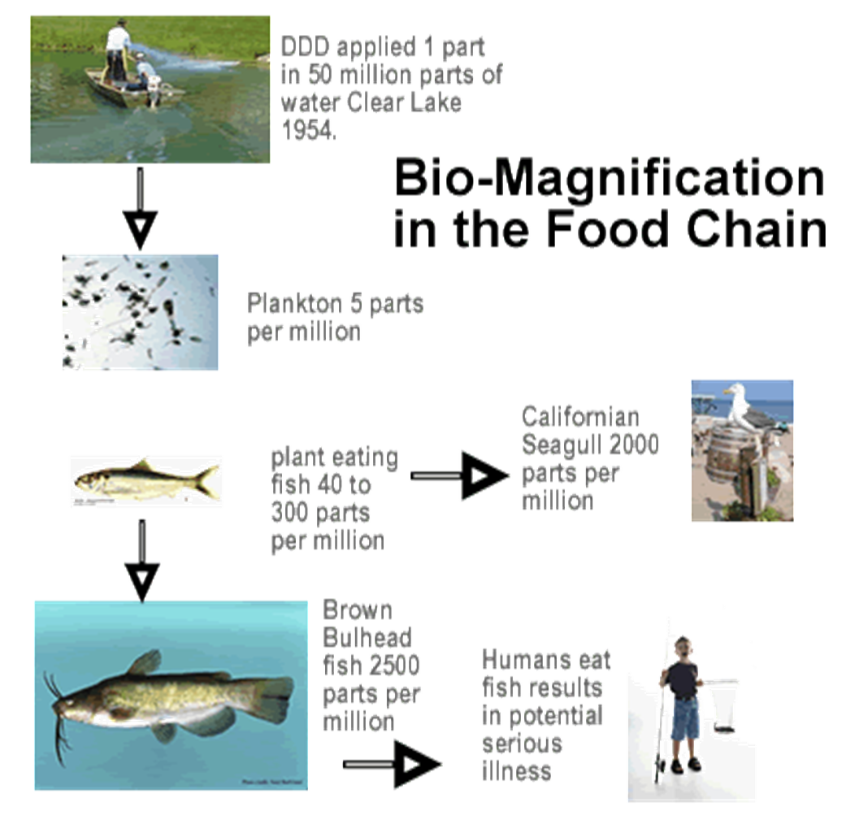

- Describe a symbiotic relationship
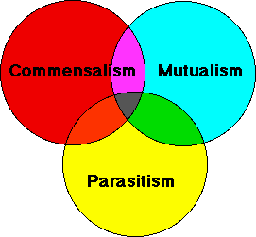

- Distinguish between the following relationships and give an example of each.
  - Mutualism

  - Commensalism

  - Parasitism

  - Predator/prey

- Give an example of each of the following phyla
PHYLA | DESCRIPTION | EXAMPLE
Porifera

Cnidaria

Ctenophora

Annelida

Arthropoda

Mollusca

Echinodermata

Chordata

