Fairfield Warde High School | David M. Ebling  Headmaster  Caryn Campbell  Director, Student Services
755 Melville Avenue • Fairfield, Connecticut 06825 • (203) 255-8449 • FAX (203) 255-8212 | Kurt Simonsenavid  Fitts Housemaster  Steven L. Fekete  Townsend Housemaster  Deirdra Preis  Pequot Housemaster  Seth Fry  Athletic Director

Chinese History, Culture & Language Warde Goes China
Fairfield Warde High School Students Friendship Exchange
An International Field Trip to China
April 7-17, 2016

September 22, 2015

Dear Families:
Save the date: it is official that we are going to China April 7th -17th, 2016!
As your son or daughter may have told you already, we have been preparing this exciting and authentic learning trip to China for interested students at Fairfield Warde High School for next spring. The Chinese club members are working closely together with me, Mandarin Chinese teacher, Ms. Kirchhoff, the PE teacher and Mr. Puskar the social studies teacher to arrange the trip preparations. This will be the third trip that FWHS students travel to China since 2007.

The detailed travel itinerary and needed communication forms will be posted on our school website http://fairfieldschools.org/schools/fwhs/ so you and your child will have a clear understanding about the experiences this very educational and extremely enjoyable international trip will offer. Imagine your child traveling and being chaperoned to China with a Beijing born Chinese language teacher (Mrs. Healy), as well as some very experienced Warde teachers to interact with local Chinese students. We will all experience the nuances of a rich culture and its’ history, while visiting China’s world famous cities, enjoying the local music, and of course the delicious cuisine that China has to offer. We will also be including a special treat and traveling to Sichuan Province where we will all see and be able to hold the world famous giant Pandas! In addition, we will be speaking and implementing what your child has been learning in my Chinese classes and history classes at Warde with other high school students in Beijing and Shanghai… what a unique experience!

Date of the Trip
The student China trip will be during the April vacation week; please save the date. The length of the trip is ten days. We will be departing on Thursday, April 7, 2016 and returning on Sunday, April 17, 2016.
We will need to bring a minimum of 22 students in order for the trip to take place, and the more students attend the less cost to each student.

Highlights of the Trip

-  Beijing, including Tiananmen Square, the Forbidden City, the Great Wall, the Summer Palace, Hutong-Chinese traditional alley and Si Heyuan- traditional Chinese architecture court yard residence. Peking Duck banquet, watch Beijing Opera or Acrobats show in the evening. The activities all correspond with our teaching and learning curriculum.

- 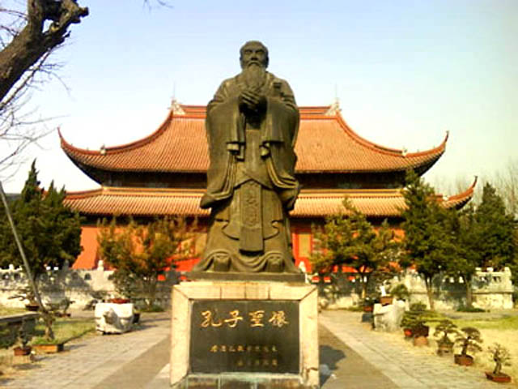 A day trip to Confucius hometown
- Interact with Chinese high school students. Visit the classes, gym and campus in famous Beijing University where we will meet with our former Warde graduate, Mary Schulman, who is studying for her masters’ degree in Chinese literature. Culture activity in evening: Chinese food Avenue, hot pot, Liu lichang (Beijing’s Soho), the night of Beijing metropolitan.

- 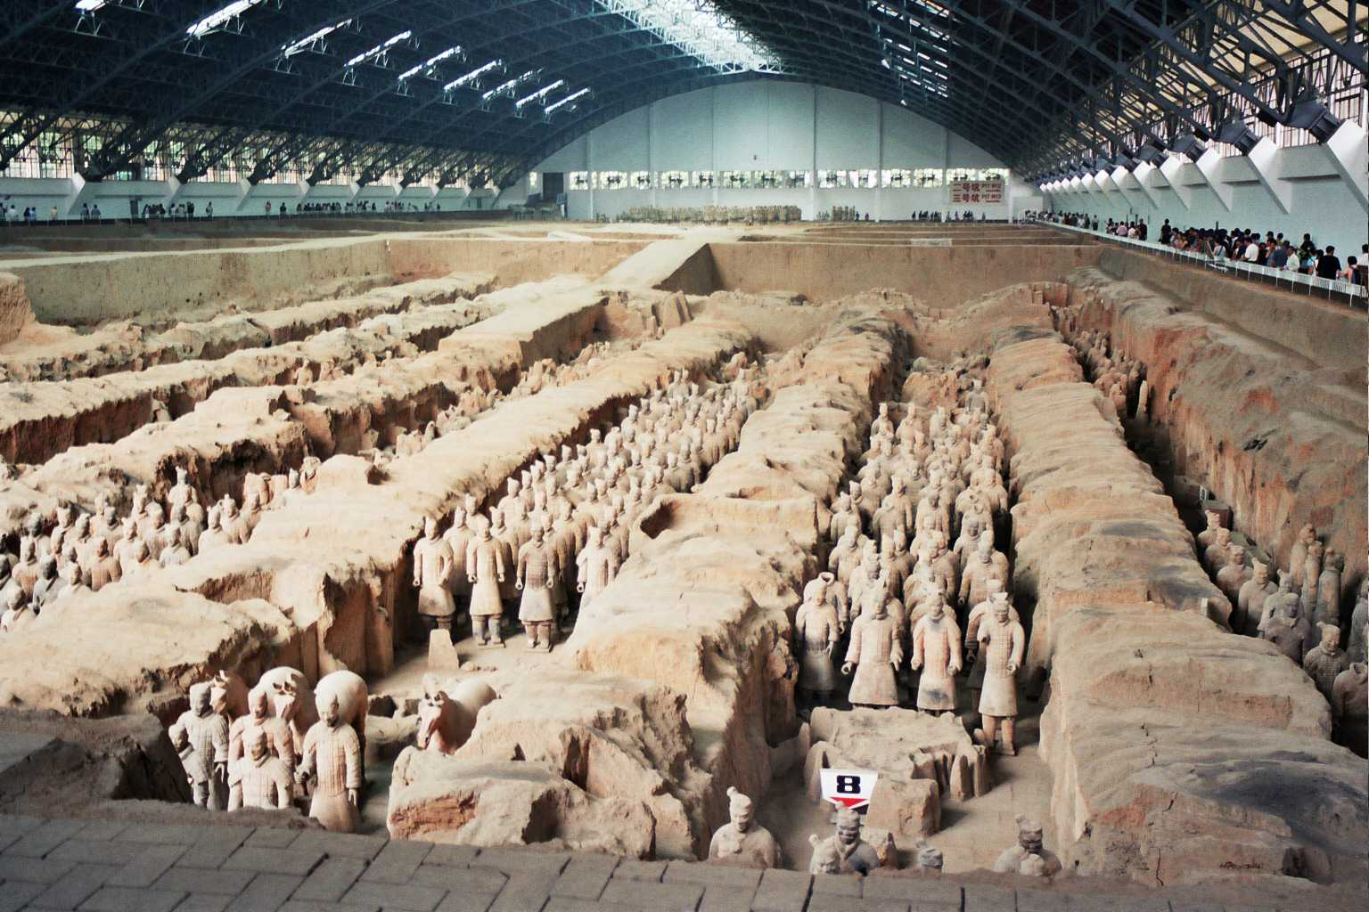 Xi’an – Excursion to Terra-cotta Warriors Museum. Old ancient city tour, biking on the City Wall and other cultural sights like Pagoda, temple and night marker. Perceive the experience from the western frontier of ancient China.

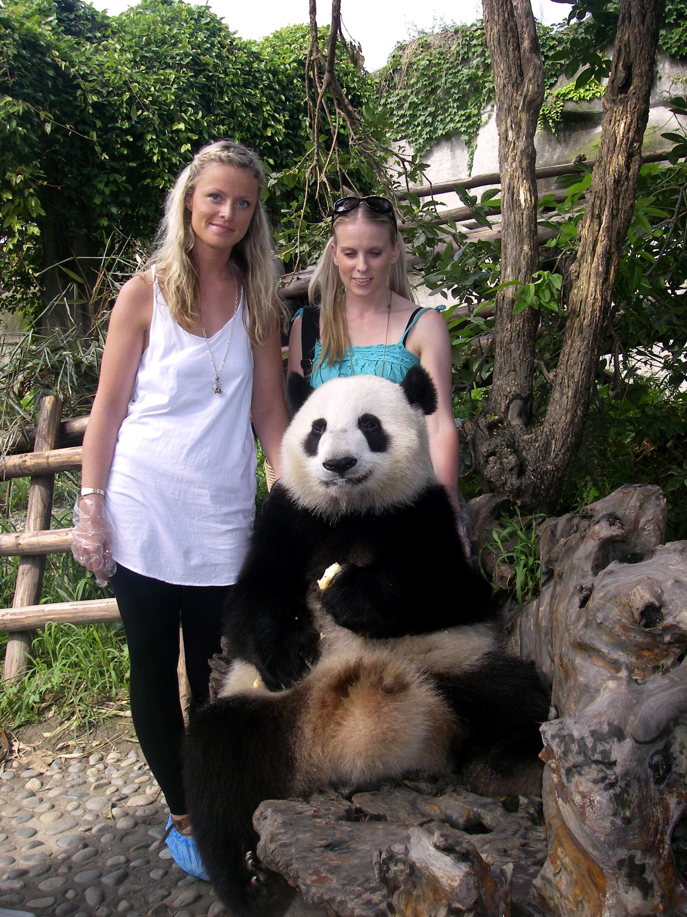
- Chengdu - Sichuan Giant Panda Sanctuaries, the historical epic towns, world oldest irrigation system

-  Shanghai- the historic section, the Bund, Yu Garden, Nanjing Road, and other local sights including 21 centre modern sections, the Pearl TV tower, the world class financial district, the Shanghai Expo and the National Arts Museum, Dr. Sun Yat-sen’s residence museum

- Boating on the ancient Grand Canal in Suzhou

Costs and Timeline
- The tentative cost of the trip will be approximately $3,100; a slight adjustment up or down may occur depending on number of participants. $20 pocket money per day is recommended.
- A non-refundable $300 deposit for the trip per person will be required by Friday, December 4, 2015 to secure the travel and airline spot.
- The $1300 airfare must be received by Monday January 4, 2016.
- Final payment will be expected by February 15, 2016.
- All applicants must obtain a passport valid through November 2016.
- There will be an additional visa fee of $180 per person. We will arrange for the required Chinese group visa through the travel agency including visa application and FedEx delivery service.

Eligibility:

All interested students must have a parent or guardian submit the attached Letter of Interest before Tuesday November 3, 2015 to Mrs. Healy in order to receive an application. Applications will then be distributed to students who meet the criteria below and it is due on November 17, 2015.
  - Applicants must be in good standing academically and be good citizens of FWHS.
  - Students will be notified with a decision regarding their application

For your calendar – Family Information Night:

There will be an important informational meeting for participants and their parent(s) or guardians on Tuesday, November 17, 2015 from 7:00 - 8:00 pm in room P7 to share detailed information regarding the trip. If you are unable to attend, please contact Mrs. Healy by email.

Fundraising for scholarship:

To help reduce the finances needed for the trip, we will invite participants to join us to fundraise in the coming months. The activities may include T-shirt sale, Chinese food sale, car wash, community tag sale, and Benefit movie nights. Please share your strategy with us.

Any questions, please contact the trip leaders:
Mrs. Rose Healy, rhealy@fairfieldschools.org Mandarin Chinese Teacher
Ms. Martha Kirchhof mkirchhof@fairfieldschools.org Physical Education Teacher
Mr. Brendan Puskar bpuskar@fairfieldschools.org Social Studies Teacher

Fall in Love with China

Chinese History, Culture & Language The Warde Goes Global: Chinese Club Presents:
"Fairfield - Beijing Students Friendship Exchange”
A Student Field Trip to China
April 7th-17th, 2016
Letter of Interest

International Field Trip to China April 7th-17th, 2016 |  |  | Yes | No
Please print:
Last Name First Name Grade & Homeroom #
My child is eligible and is interested in applying for the trip

If my child’s application is approved, I will attend the Orientation Meeting on
Tuesday 11/17/2015, 7:00 - 8:00 pm, P7
My child is interested in participating in fundraisers to help set up scholarship to the defray the costs of the China Trip
My child takes Chinese class _Yes No___

Name of other social studies class ____________________
Please print and send this Form to Mrs. Rose Healy at FWHS, P-7 by 9/28/2015

Student signature: ______________________________ Date: _____________________
Contact email: ___________________________________ Cell:_______________________

Parent/Guardian signature: ___________________ Date: ____________________
Contact email: ____________________________________ Cell:_______________________

“Fall in Love with China”

Important Dates

Item | Due | Where
Letter of Interest for the china Trip | Tuesday, November 3, 2015 | Mrs. Healy P7
Application Forms | Tuesday, November 17, 2015 | Mrs. Healy P7
Valid passport through November 2016 | Students must apply for one ASAP!!
Family Information Night | Tuesday, November 17, 2015  7:00 - 8:00 pm | Room P7
Fundraising for scholarship | TBD | TBD
Payment Schedule:
Non-refundable $300  to secure the travel and airline spot | Friday, December 4, 2015 | Mrs. Healy P7
$1300 airfare | Monday, January 4, 2016 | Mrs. Healy P7
Final balance of $1320 payment | Monday, February 15, 2016 | Mrs. Healy P7
visa fee of $180 | Monday, February 15,2016 | Mrs. Healy P7
Traveling:
Leave FWHS by school bus to Airport | April 7, 2016 | FWHS-NYC
In China | April 8 -17, 2016 | 5 China major cities
Return to FWHS by school bus | April 17, 2016 | FWHS

