Culinary 10 Getting Started
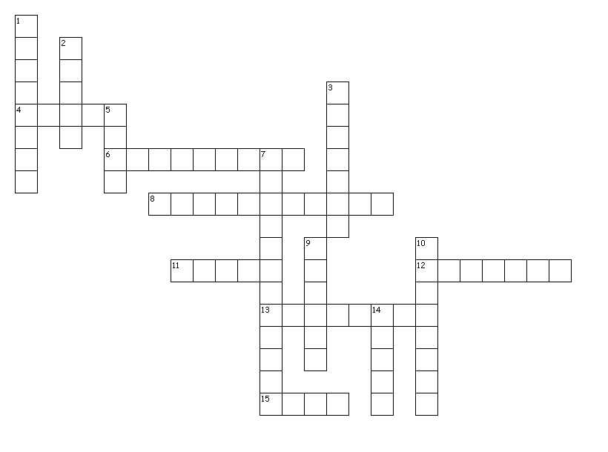

Across
4. The proper knife grip requires you to ________ the heel of the knife with your thumb and forefinger
6. Foods that emit a distinctive aroma and often have a strong flavor.
8. We only use these to dry our hands.
11. A method that requires you to combine dry ingredients, work in a solid fat, then add liquid to form a stiff dough
12. When cutting, keep the tip of the knife on the cutting board and use a _______________ motion to go through the food.
13. When cutting something, the hand that you're holding the food with should be in a ___________________.
15. When carrying a knife, walk with it pointed straight __________ along your side.
Down
1. Equal amounts of carrots, celery, and onion; used as a base for many dishes
2. To combine two or more ingredients until you can no longer see either ingredient separately.
3. When done using a knife, place the used knife on the __________, next to the sink
5. In order to cook an egg more evenly, place a lid on the pan to hold in __________.
7. When cutting something, the food should always be placed on a ______________________.
9. When rolling out dough, be sure to ______________ it in order to maintain a round shape.
10. Using an egg wash helps to enhance __________ in your finished product.
14. When measuring flour, fill the measuring cup until it's overflowing and then _______________ it.

15 of 15 words were placed into the puzzle.
Created by Puzzlemaker at DiscoveryEducation.com

