Graphing Guide Name:___________________________
Date: _______________ Period: _____

Always give the graph a title that lets the reader know what the graph represents.
Include your NAME on the graph

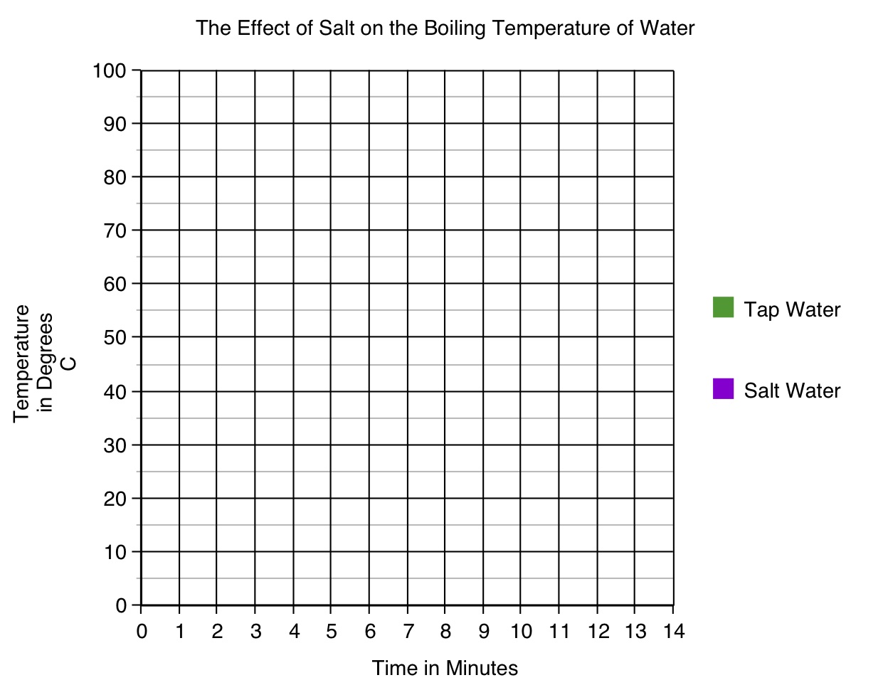
When hand-drawing the lines on your graph, use a ruler
Your scale does not have to label each line. It should avoid clutter and make your graph easy to read.
Include a key to explain all symbols / colors used.
Label BOTH of the axes:

X-Axis ( ) = Independent Variable
Y-Axis () = Dependent Variable

Labels should include:

- The QUANTITY it measures (ex. Time)
- The UNITS it’s measured in (ex. Minutes)
Plan ahead to insure that:

- The scale intervals on your X and Y axis are equal.

- Your scales use as much of the available space on the graph paper as possible.

