Name: _________________________________________ Date: _________
Period 3 4 5 6 7 Physical Science

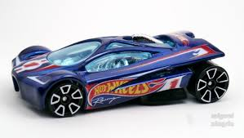
Lab Report
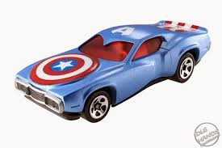
Attach to this report:
- Your graph
- Your data tables

Hypothesis:

Conclusion

- Was your hypothesis correct? Support your answer with data.

Reflection

- How reliable you think your data is? In other words, how much confidence do you have in your accuracy? Describe any difficulties or possible sources of error that may have affected your results.

