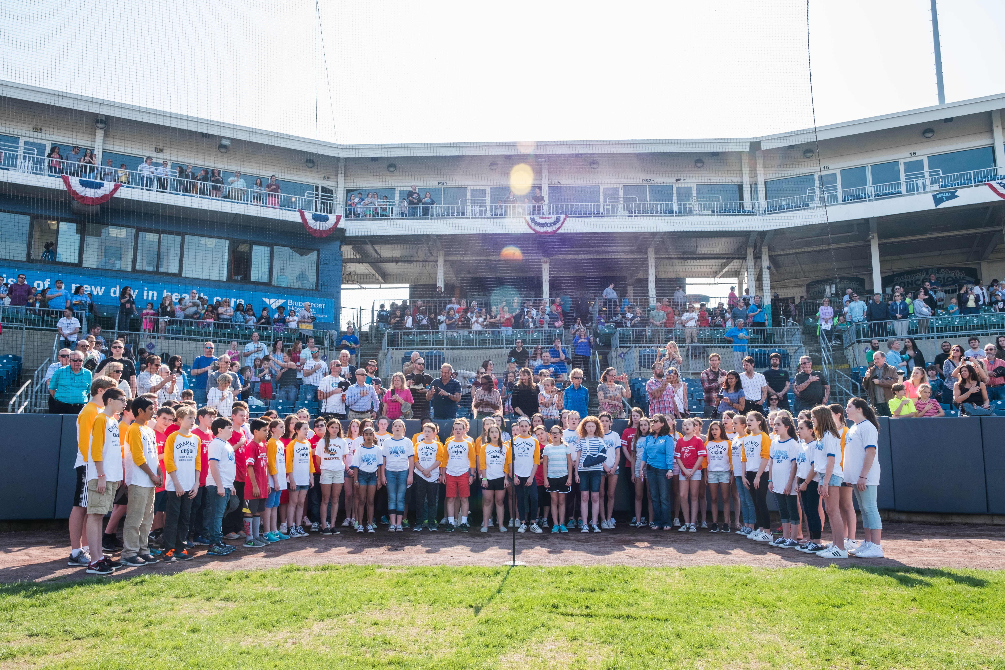
7th grade CHORUS
SCHEDULE: 3 days/week or 1 day/week for instrumentalists all year
GRADING: 3x/week Chorus students will be graded every marking period. Band & Orchestra Chorus students will be graded 2nd and 4th quarters based on Rehearsal and Choral Techniques Dailey Rubric (over).
CONCERT MUSIC: 7th grade Chorus music is chosen based on difficulty level and variety of styles including Multicultural and Pop. We will perform in two (SA) and three (SSA or SAB) parts.
BEHAVIOR CONTRACTS: Music Dept. Behavior contracts are due Friday, Sept. 15th. Please read the orange contract with two wildcats at the top to understand our large group classroom expectations.
PIE SALE: The Music Dept. Pie Sale will run from September 7th until September 28th. Proceeds from the sale will help pay for coach buses to the 7th grade music students to attend a concert or Broadway show in New York City. Delivery of the frozen pies will be Saturday, November 18th from 9am – 11am in the FWMS cafeteria.
NY CITY BEHAVIOR REWARD TRIP: Plans have begun for a Broadway show matinee on Saturday, June 9th – stay tuned!
VOCAL MUSIC EXTRA CURRICULAR ACTIVITIES
MADRIGALS: Is now a fall afterschool club for 7th & 8th graders on Mondays & Wednesdays from September – mid-December that will perform a dinner theater style Medieval Feast. Opportunities for acting, creative writing, sword fighting, juggling, singing, trumpeting serving, cooking, dancing & “puppeteering” are available.
CHAMBER CHOIR: is open to all grade levels. Audition sign-ups sheets are in room C162. Rehearsals are THURSDAY mornings from 7:20 – 8am beginning September 26th. Chamber Choir performs at eight school and community events throughout the year. More details may be found of the Chamber Choir page by going to TEACHER PAGES – MS. FRAWLEY – CHAMBER CHOIR.
DRAMA CLUB: Auditions will take place early February. Rehearsals run afterschool February – March. Two shows will be performed in April. A full schedule of days and times and our Audition Letter will be posted on the FWMS Homepage – ACTIVITIES – DRAMA CLUB. This year’s show TBD.

2018 CONCERT DATES
Thursday, January 11th & Tuesday, MAY 22nd at 7pm

