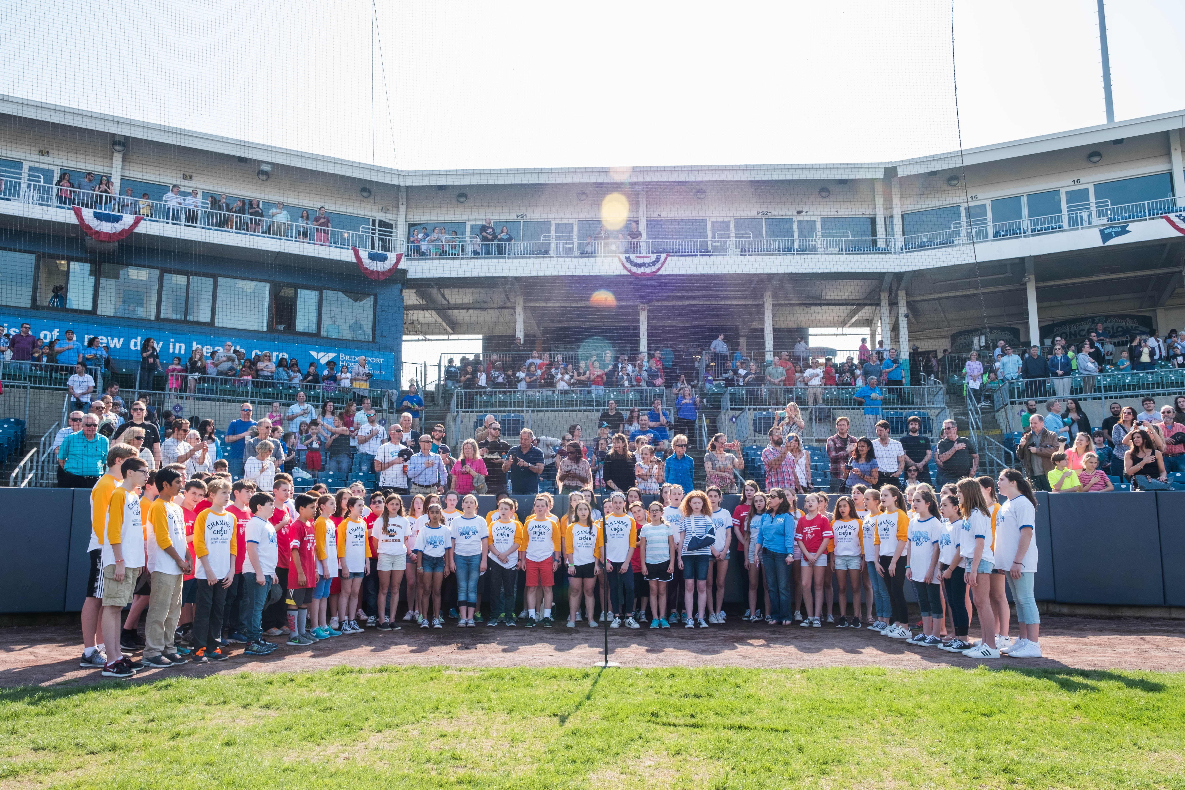
8th grade CHORUS
SCHEDULE: 3 days/week or 1 day/week for instrumentalists all year
GRADING: 3x/week Chorus students will be graded every marking period. Band & Orchestra Chorus students will be graded 2nd and 4th quarters based on Rehearsal and Choral Techniques Dailey Performance Assessment Rubric. (over)
CONCERT MUSIC: 8th grade Chorus music is chosen based on difficulty and variety of styles including Broadway and Gospel/Spiritual. We will perform in two (SB), three (SAB), and four parts (SATB).
BEHAVIOR CONTRACTS: Music Department Behavior Contracts are due Friday, Sept 15th. Please read the orange contract with two wildcats at the top to understand our large group classroom expectation.
PIE SALE: The Music Dept. Pie Sale has just begun and will run from September 7th – September 28th. Proceeds from the sale will help pay for coach buses for 8th grade music students to attend a Broadway show in New York City and High School Winter concerts. Delivery of the frozen pies will be Saturday, November 18th at 9am – 11am in the cafeteria.
BROADWAY SHOW TRIP: Plans have begun for a matinee on Saturday, June 9th for 8th graders. Stay tuned!
FIELD TRIP TO CARILLON/CANDELIGHT CONCERTS: All 8th grade music students will be invited to see the Fairfield Warde/Ludlowe Music Department’s perform their Holiday Concert on December 20th at 9am. Look for permission slips to come home in November.
VOCAL MUSIC EXTRA CURRICULAR ACTIVITIES
MADRIGALS: Is a fall afterschool club for 7th & 8th graders on Mondays & Wednesdays from September - mid-December that will perform a dinner theater style Medieval Feast. Opportunities for acting, creative writing, sword fighting, juggling, singing, trumpeting, serving, cooking, dancing & “puppeteering” are available.
CHAMBER CHOIR: Audition sign-ups have started and will begin next week. Rehearsals run all year and on THURSDAY morning from 7:20 – 8:00am beginning September 26th. Chamber Choir performs at eight school and community events throughout the year.
DRAMA CLUB: Auditions will take place early February. Rehearsals run afterschool February– March. Two show will be performance in April. A detailed schedule of days and times and our Audition Letter will be on line ASAP. FWMS Homepage – ACTIVITIES – DRAMA CLUB. Show title TBD.

2018 CONCERT DATES:
Wednesday, January 17th & Thursday, MAY 24th at 7pm

