Drama Club Cast T-Shirt Order Form
First & Last Name____________________________________________________
Size (please circle): Youth Large Adult Small Adult Medium Adult Large Adult XL
T - Shirt will be short sleeve ocean blue with teal ink
Cost: $17.00 CASH ONLY PLEASE (we cannot accept any checks)
in an envelope with this form & size choice!
Payment due by Monday, March 5th rehearsal
Front small left chest :
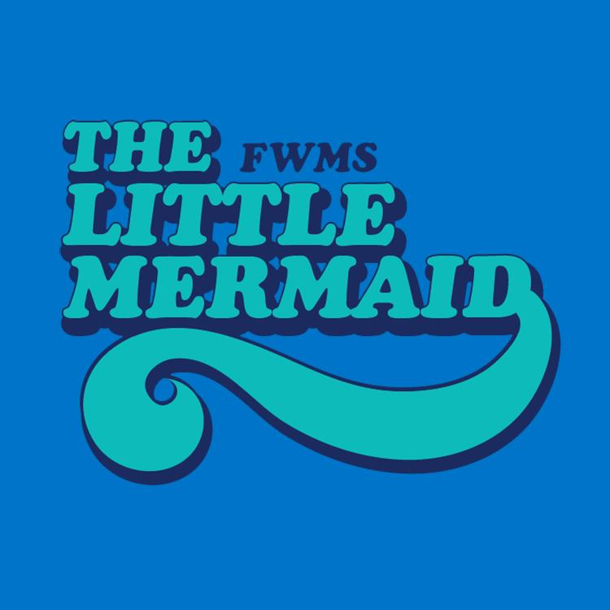
Back center large:
Drama Club Crew T-Shirt Order Form
First & Last Name____________________________________________________
Size (please circle): Youth Large Adult Small Adult Medium Adult Large Adult XL
T - Shirt will be short sleeve black with grey & white ink
Cost: $17.00 CASH ONLY PLEASE (we cannot accept any checks)
in an envelope with this form & size choice!
Payment due by Monday, March 12th rehearsal
Front small left chest :
Back center large:

