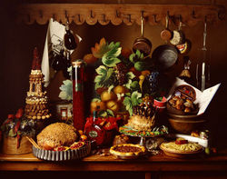

Here ye! Here ye!
There is a feast as ye may see.
On a royal day in 1493 – a last month feast.
In the warmth of Fairfield Woods Castle at least.
While the wind whips cold outside – entertainment in the eveningtide!
We will enlighten thee – we invite thee to the 30th annual FWMS Madrigal Feast on 16th December night.
Join us tween the chimes of six to eight – don’t miss this date!

RSVP on or before December 7th
********************************************************
Feast Reservation
Baked potato soup, Baked chicken, corn, green beans
& pumpkin pie at $15 per meal

Madrigal student plus ______guests & meals
Cash only please (as checks had not yet been invented)
Total enclosed: $____________

_________________________________________________________
Please clearly print all guests first & last names

Ye 30th Annual FWMS Madrigal Feast

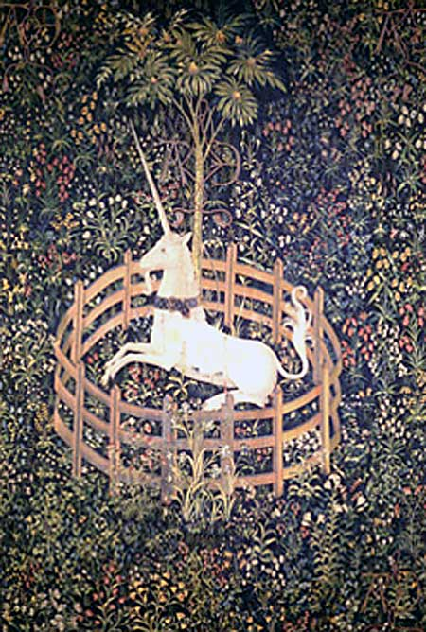

Here ye! Here ye!
This invitation you shall see is a royal invitation made for thee.
At Fairfield Woods Castle ye shall enter
to behold a Madrigal Feast full of splendor.
The times allotted be 6pm – 8pm. And ye shall not be a moment late.
For tis the times of good tidings. We are filled with cheer.
This is the perfect celebration to end the year!

RSVP on or before December 7th
********************************************************
Feast Reservation
Baked potato soup, Baked chicken, corn, green beans
& pumpkin pie at $15 per meal

Madrigal student plus ______guests & meals
Cash only please (as checks had not yet been invented)
Total enclosed: $____________

_________________________________________________________
Please clearly print all guests first & last names

