FAIRFIELD WOODS MIDDLE SCHOOL
DRAMA CLUB 2019
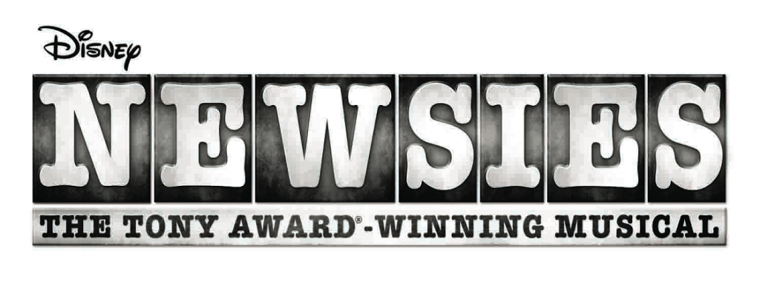
Jack Kelly - Kyle Geriak
Crutchie - Nicky Faustini
Davey - Adam Petrosino
Les - Lucas Richerson
Race – Ali Markus
Albert - Siya Bajaj
Specs - Alex Rosenberg
Henry- Quinn McCormack
Finch- Catherine Melody
Romeo - Stephen Petrosino
Elmer - Briscian Belizaire
Mush - Amelia Keresy
Buttons - Griffin Harwood
Splasher – Amari Gray
Tommy Boy - Amelia Melody
Jo Jo - Luke Silence
Mike – Emmy Joyce
Ike - Ainsley Dahlstrom
Spot Conlon – Isabel Toma
Newsies: Zoe Eldridge, Gillian Applebaum, Tatum Sheehey, Caroline Keresey, Nicole Curi

Katherine Plumber – Marissa Curti
Darcy - Aidan Guernsey
Bill – Jackson Weber
Wiesel - John Curi
Morris Delancey - Sebastian Castro
Oscar Delancey - Matt Pastor
Joseph Pulitzer - Julian Alcaraz
Seitz - Nathaniel Taft
Bunsen - Nicholas Ta
Hannah - Maddie Markham
Nunzio – TBD
Guard - TBD
Snyder - Nate Balavender

Medda Larkin - Kat Foley
Bowery Beauties: Isabella Baptista, Ishita Kumar, Grace Farrell, Leighton Davis, Lyla Della Porta,
Ellie Antrobus, Natalia Godo, Zoe Zwerlein
Stage Manager - Hannah Murray

Mayor - Sierra Hall
Nuns: Hannah Murray, Sophie Pennock Collins, Natalie Parent
Mrs. Jacobi - Margaret Carroll
Governor Teddy Roosevelt - Liam Cadavid

