# FAIRFIELD WOODS MIDDLE SCHOOL

## 1115 Fairfield Woods Road

Fairfield, CT 06825

Phone: 203-255-8334 Fax: 203-255-8210

#### Gary A. Rosato, Ed.D. Ken Seltzer Karin Shaughnessy

#### Principal Assistant Principal Assistant Principal

#### 

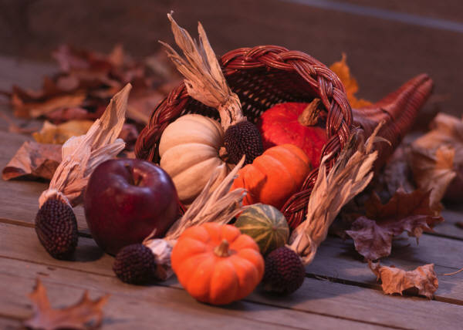

November 25, 2014

Dear Fairfield Woods Families,

I am writing on behalf of the full staff at Fairfield Woods as we approach this Thanksgiving holiday. We all know that life has its challenges, however, we still have so much to be thankful for and each year at this time, it is important to take stock of our blessings. All of us at school are thankful for you, the parents and guardians of our school community. We greatly appreciate all the ways you support the school program and, in particular, are grateful for our PTSA leadership and all the volunteers who continue to give their time and energy on behalf of the students and staff at Woods. Thank you!

This Thanksgiving, as you take time to enjoy the company of family and friends and, of course, some really good food, please know that all of us at Woods wish you and your family peace, health and happiness during this holiday season. This is a special time of year with much to celebrate, but nothing is more valuable than the gift of family and friends. Enjoy the time together.

From all of us at Fairfield Woods, Happy Thanksgiving!

Sincerely,

Gary Rosato

Gary Rosato

Principal, Fairfield Woods Middle School