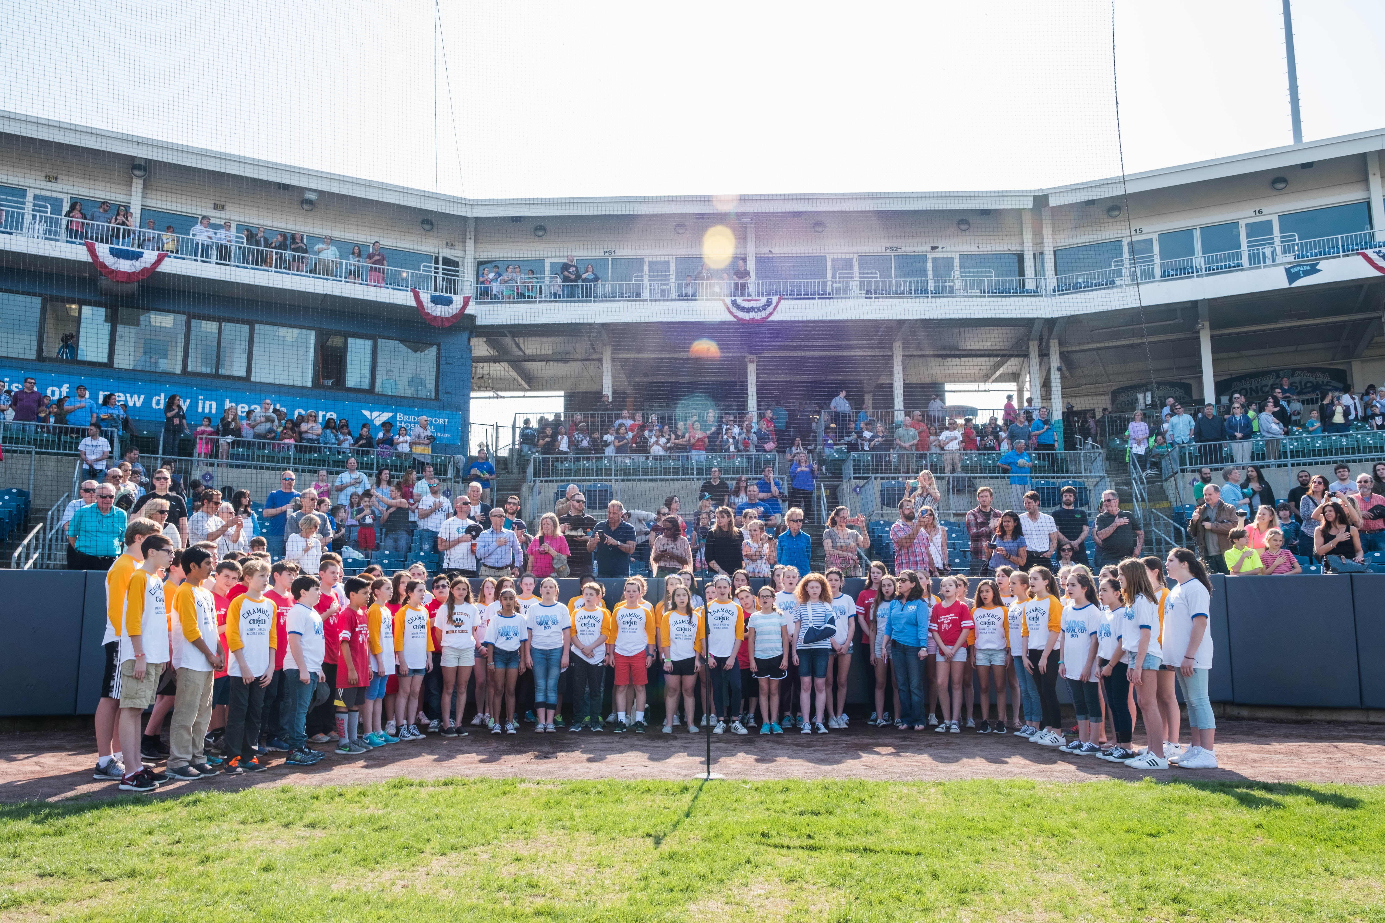

6th grade CHORUS
SCHEDULE: 3 days/week or 1 day/week for instrumentalists all year
GRADING: 3x/week Chorus students will be graded every marking period. Band & Orchestra Chorus students will be graded 2nd and 4th quarters based on Rehearsal & Choral Techniques Dailey Rubric.
CONCERT MUSIC: 6th grade Chorus music is chosen based on difficulty and variety of styles that will include Classical & Jazz. We will perform in two (SA) and three (SSA) parts.
BEHAVIOR CONTRACTS: Music Department Behavior Contracts are due Friday, Sept 15th. Please read the orange contract with two wildcats at the top to understand our large group classroom expectations.
PIE SALE: The Music Dept. Pie Sale will run from Sept. 7th – September 28th. Proceeds from the sale will help pay for coach buses for 6th grade music students to attend a Jazz at Lincoln Center Concert in New York City on Friday, November 17th. Delivery of the frozen pies will be Saturday, November 18th 9am – 11am in the cafeteria.
NEW YORK CITY TRIP: Jazz at Lincoln Center Concert in New York City on Friday, November 17th. The title of the concert is “Who is?” Permission slips coming soon!
VOCAL MUSIC EXTRA CURRICULAR ACTIVITIES
CHAMBER CHOIR: Audition sign-ups have started and will begin next week. Rehearsals run all year and on Thursday morning from 7:20 – 8:00am beginning September 26th. Chamber Choir performs at nine school and community events throughout the year.
DRAMA CLUB: Auditions will take place early February. Rehearsals run afterschool February and March. We perform two shows in April. A full schedule of days and times and our Permission slip/Audition Letter will be on line ASAP. Show title TBD

2018 CONCERT DATES
Wednesday, January 10th & Thursday, May 17th at 7pm

