7th grade Chorus Spring Study Sheet

NOTE NAMING RULES:
- Musical alphabet = A B C D E F G
- Always count lines or spaces from the bottom of the staff up to the top
- Treble & bass clefs are NOT the same letters (starting notes are different but the pattern is the same)
- Letter names are alphabetical combining lines & spaces – make sure you start on the correct letter
- Leger lines continue in the alphabetical pattern above & below the staves
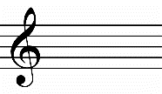
Treble clef curl in the middle ends on the 2nd line G Treble or G clef lines: E G B D F spaces: F A C E
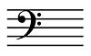
Bass clef dots surround the 4th line F Bass or F clef lines: G B D F A spaces: A C E G
VOCABULARY:
Accelerando – gradually speeding up
Diminuendo – gradually get softer
Enumeration – musical counting
Fermata - hold
Fortissimo – very loud
Key Signature – sharps or flats at the beginning of each line determining DO
Pianissimo – very soft
Piano part – accompaniment written on a grand staff 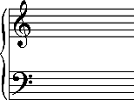
Repeat sign – go back to either beginning or previous repeat sign
Ritardando – gradually slowing down
Sforzando – suddenly loud
Slur – curved line between notes on different places on the staff indicating smooth
Tempo marking – rate of speed
Tie – curved line between notes on the same place on the staff that adds length
Time signature – top number tells how many beats per measure & bottom tells which note gets the beat

