8th grade Chorus Spring Study Sheet
NOTE NAMING RULES REVIEW:
- Musical alphabet = A B C D E F G
- Always count lines or spaces from the bottom of the staff up to the top
- Treble & bass clefs are NOT the same letters (starting notes are different but the pattern is the same)
- Letter names are alphabetical combining lines & spaces – make sure you start on the correct letter
- Leger lines continue in the alphabetical pattern above & below the staves
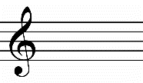
Treble clef curl in the middle ends on the 2nd line G Treble or G clef lines: E G B D F spaces: F A C E
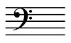
Bass clef dots surround the 4th line F Bass or F clef lines: G B D F A spaces: A C E G
VOCABULARY:
Accent – 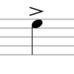 sing with more emphasis
Accidental – a flat, sharp or natural that is not indicated in the key signature
D.S. al Coda – Go back to the sign, then to the coda
Enumeration – musical counting
Fermata – 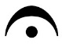 hold until conductor cut off
Key Signature – sharps or flats at the beginning of each line determining DO
Piano part – accompaniment written on a grand staff 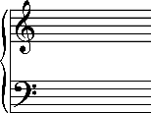
Sixteenth note 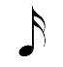& rest 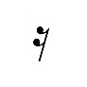– ¼ of a beat
Solfege – a system for singing notes using syllables (do, re, mi, fa, sol, la, ti, do)
Slur – 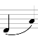curved line between notes on different places on the staff indicating smooth phrasing
Staccato – 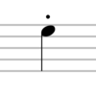short & detached notes
Tie – 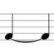curved line between notes on the same place on the staff that adds duration
Time signature – top number tells how many beats per measure & bottom tells which note gets the beat
Unison - singing the same pitch

