FWMS Chamber Choir T-shirt
$17
Order form
Name______________________________________________________________
Check #_________________ (payable to FWMS) or Cash________________

Circle Size: Youth Large Adult Small Adult Medium Adult Large Adult X-Large
Please consider that we use the same shirts for all years of Chamber Choir when choosing your size!
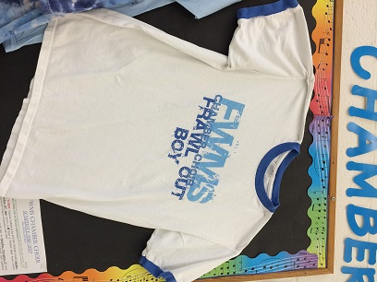
Pre-shrunk 100% cotton
Adult Large pictured & displayed on my bulletin board.
Make checks payable to FWMS & due by Friday, October 7th

