1-B Special Schedule

A Day- 9:15 Music 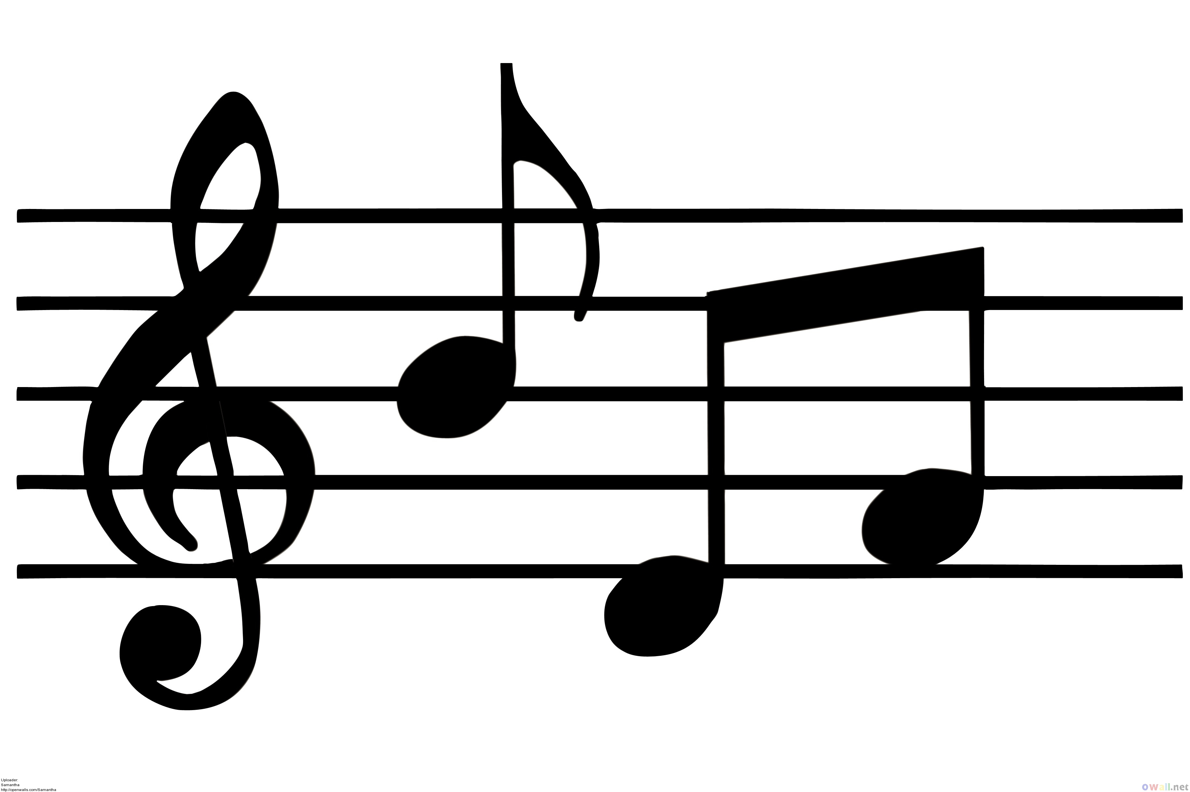
2:00 Book Exchange

B Day- 12:45 Art

C Day- 12:45 P.E.

D Day- 1:15 Music

E Day- 9:15 LLC

12:45 P.E.

