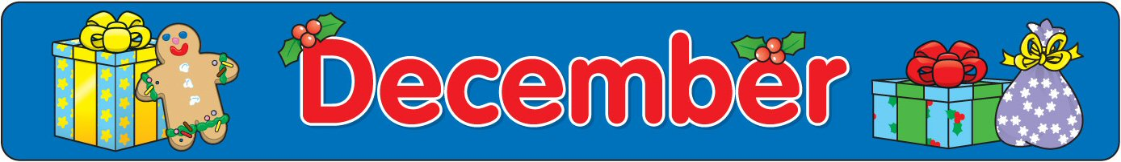
Sun | Mon | Tue | Wed | Thu | Fri | Sat
 | 1 -B | 2 -C  Ct River  Workshop  4th Grade | 3 -D | 4 -E | 5 -A | 6
7 | 8 -B | 9 -C | 10 -D | 11 -E | 12 -A | 13
14 | 15 -B | 16 -C | 17 -D | 18 -E | 19 -A  Winter  Solstice  Celebration | 20
21 | 22 -B  Class  Holiday  Party  1:00 | 23 -C  Holiday  Sing a-Long  2:30 | 24  No School | 25  No School | 26  No School | 27
28 | 29  No School | 30  No School | 31  No School

