[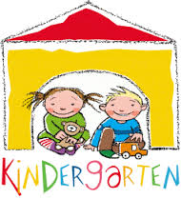](http://www.google.com/imgres?imgurl=http://educatehopkinton.com/wp/wp-content/uploads/2014/01/kindergarten.gif&imgrefurl=http://educatehopkinton.com/tag/full-day-kindergarten-2/&h=262&w=238&tbnid=e4eMHObBvU-tFM:&zoom=1&docid=09mSWPGxPzOOAM&ei=KzMsVKP0IpKayAS-p4GoBA&tbm=isch&ved=0CD0QMygKMAo&iact=rc&uact=3&dur=447&page=2&start=7&ndsp=14)