KO Specials Schedule

A Day Music 1:15-1:45
B Day Library Learning Commons 9:30-10:15
B Day P.E. 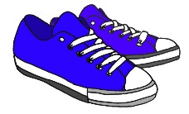1:15-1:45

C Day Music 1:15-1:45

D Day Art 12:45-1:15

E Day P.E. 9:15-9:45

Please return books on Library Learning Commons day.
Please wear sneakers on P.E. days.

