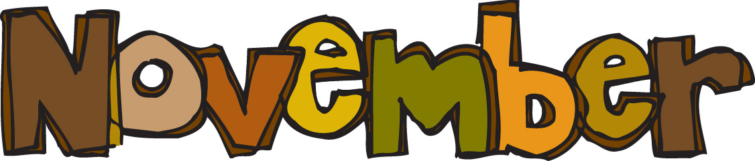
Sun | Mon | Tue | Wed | Thu | Fri | Sat
 |  |  |  |  |  | 1
2 | 3 -A | 4  No School  Election  Day | 5 ~B | 6 ~ C | 7 ~ D  FAY performance  “Arithmetickles”  10:20 | 8
9 | 10 ~ E  Character  Assembly  (Time – to be announced) | 11  No School  Veteran’s  Day | 12 ~ A | 13 ~ B | 14 ~ C | 15
16 | 17 ~D | 18 ~E | 19 ~ A | 20 ~ B | 21 ~ C | 22
23 | 24 ~ D | 25 ~ E  Turkey Trot  8:30 | 26 ~ A  1:30  Dismissal | 27  Happy  Thanksgiving | 28  No School  Thanksgiving  Recess | 29  