First Grade News
January 11, 2016

Dear Parents,
We hope you had a great weekend. Here’s our news!

Phonics/Penmanship
The new words for this week are: boy, girl, big, in, they.
Including this week’s words, we have now introduced 55 word wall words this year. Below you will find a list of all 55 introduced words. Please keep this list at home to practice!

Writing
As we finish up our work with nonfiction teaching books, we have been working on editing and revising our work carefully. Going back and rereading a story is not something that most first graders typically do on their own. It is something that they are learning to do as they work on their piece each day. While editing, the students have learned that there are particular things to keep an eye out for. Here is a poster that we use in our classrooms during writing.

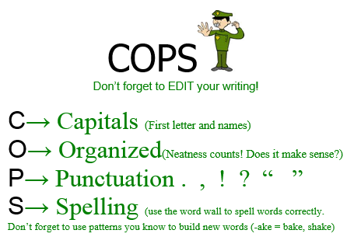
Math
This week our learning shifts to fractions. We will be learning that fractions are equal parts of a whole. Today we kicked off our learning by trying to divide imaginary cakes into fair shares. We started off by trying to divide the cake so that 2 friends could share it. Then, we tried to divide another cake so that 4 people could share it. We learned about halves and fourths.

Health
Scrubby Bear has been teaching our classes about germs and the importance of handwashing. The students have learned that germs live everywhere – in the air, in food, in water, on objects, and even on our bodies! The students have reviewed ways to prevent the spread of germs by practicing good personal hygiene. We have also learned the 6 steps for handwashing. Last week the students received a chart to help them keep track of their handwashing for homework. When they bring the completed chart back to school, the will become an official member of the Scrubby Bear Clean Hands Club!!!! They will receive a membership card as soon as the completed chart is handed in. How exciting!!

Respectfully yours,
Abigail Barzottini
Allison Cabezas
Debbie Jacobs

**See word wall words below!

Word Wall words as of 1-11-16

