First Grade News
January 4, 2016

Dear Parents,
Happy New Year! We hope you enjoyed the vacation time with your wonderful children.

We want to send a huge Congratulations to Mrs. Cabezas who got engaged over the break!!

Reading Workshop:
We are continuing our unit called Appreciating Fiction through the Characters’ Eyes. Below are questions that are used in the classroom to extend thinking. Please use them at home while reading with your child.
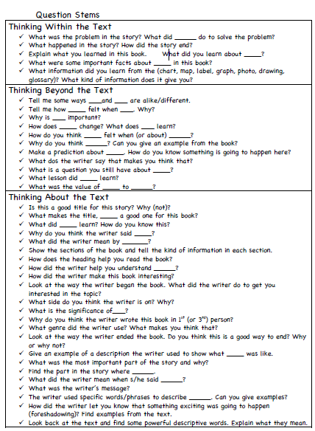
Phonics/Penmanship:
This week’s words are: make, not, new, for, my. Please use the spelling menu to complete at least 3 activities at home. We will be having a Word Wall Test on these words on Friday.

Writing:
We are continuing our writing of nonfiction chapter books. The students have learned that authors add introductions and conclusions to their writing as a thoughtful way to begin and end books.
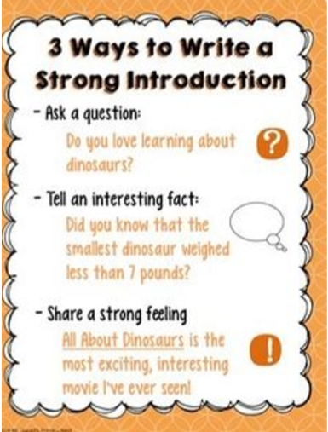
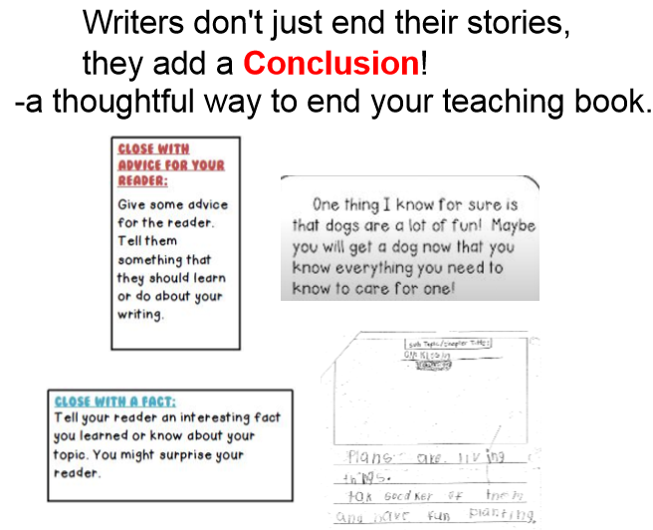

Math:

We are continuing our learning of 2D shapes. We learned that shapes can defining attributes are

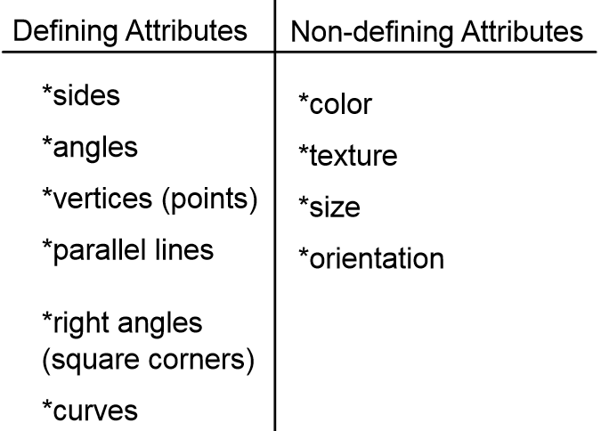

Respectfully yours,

Abigail Barzottini
Allison Cabezas
Debbie Jacobs

