1J Special Schedule
A | B | C | D | E | F
P.E.  12:50-1:30  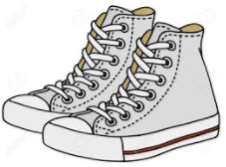 | Music  9:10-9:50 | P.E.  12:50-1:30 | Music  12:50-1:30 | Library Learning Commons (LLC)  12:50-1:30  Book Exchange  1:30-1:50 | Art  12:50-1:45
2017-2018

Recess 12:00-12:20
Lunch 12:25-12:45

