Mrs. Jacobs’ Class
2018-2019

Henna Belli
Nathan Bloom
Lowie Channell
Charlotte Curran
Emma DellaVolpe
Laura Fadul
Ethan Graf
Sabrina Graser
Noah Hoffmann
Mickey Jobst

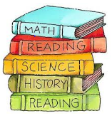

Lucas Kuen
Leo Kurtz
Max Montero
Connor O’Brian
Anaira Parvatikar
Jack Pestka
Nicolas Rodon
Cooper Sullivan
Julia Van Popering
Austen Zerfass

