Mrs. Jacobs’ Class
2017-2018

Valentina
Maggie
Shea
Aidan
Calvin
Henry
Maddy
Alex
Eli
Dylan
Crystal
Total students = 22
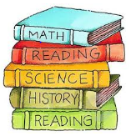

Shayna
Theo
Charlotte
Lily
Ben
Mila
Adrianna
Julia
Liam
Olivia
Brayden

