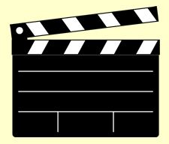

Book title:___________________________________ Your name:___________________________________

Book Trailers

- Are a great way to promote your book to classmates and encourage them to read it too.
- Are also a great way to get recommendations from friends.
- They are long enough to spark curiosity about the book but short enough to not give away too many details.

Details to think about while you are reading the book:
What happens in the book? Outline the plot. Summarize the story.

Describe the main character or other important characters.

Explain the conflict or the challenge.

Talk about the setting. Place, time, interesting facts.

What are the big ideas behind the story?

What was your favorite aspect of the book?

Why did you like it so much?

Why do you think other people will like it?

Who is the author? Does the author have other familiar books?

What other book does this remind you of?

