Name:______________________________________________________ 9/25/17
Reading Homework - Theme vs. Main Idea
Directions: Read passages A and B. Answer the questions that follow.
Passage 3
What is this passage mostly about (main idea)?
__________________________________________________________________
__________________________________________________________________
__________________________________________________________________
__________________________________________________________________
What is one possible theme (written as a sentence) for this passage?
__________________________________________________________________
__________________________________________________________________
__________________________________________________________________
__________________________________________________________________
Passage 4
What is this passage mostly about (main idea)?
__________________________________________________________________
__________________________________________________________________
__________________________________________________________________
__________________________________________________________________
What is one possible theme (written as a sentence) for this passage?
__________________________________________________________________
__________________________________________________________________
__________________________________________________________________
__________________________________________________________________
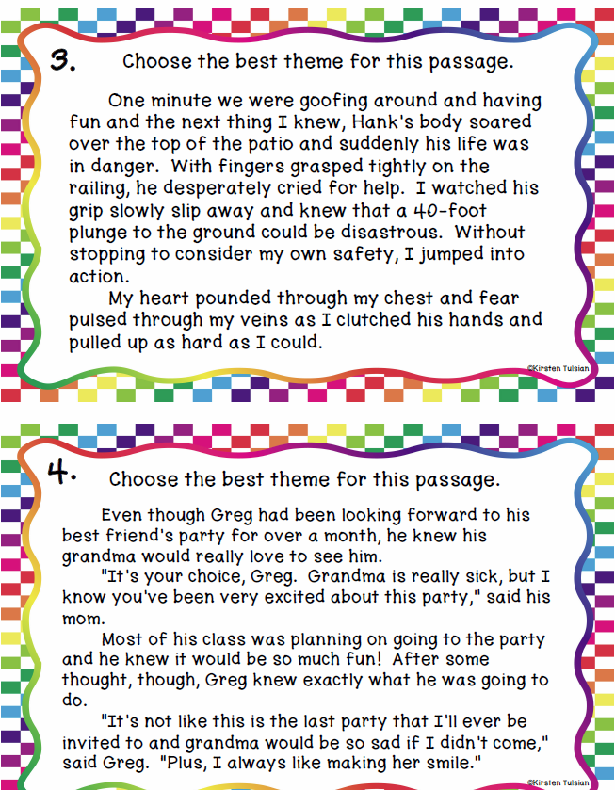

Name:______________________________________________________ 9/25/17
Theme vs. Main Idea
Directions: Read passages 1 and 2. Answer the questions that follow.
Passage 1
What is this passage mostly about (main idea)?
__________________________________________________________________
__________________________________________________________________
__________________________________________________________________
__________________________________________________________________
What is one possible theme (written as a sentence) for this passage?
__________________________________________________________________
__________________________________________________________________
__________________________________________________________________
__________________________________________________________________
Passage 2
What is this passage mostly about (main idea)?
__________________________________________________________________
__________________________________________________________________
__________________________________________________________________
__________________________________________________________________
What is one possible theme (written as a sentence) for this passage?
__________________________________________________________________
__________________________________________________________________
__________________________________________________________________
__________________________________________________________________

