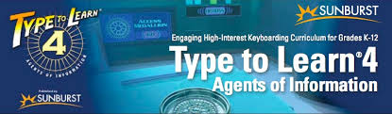
Our school district has now acquired TTL 4 (Type to Learn 4) which allows families to download it on both Windows and Macs. If you wish to download it on your home computer please click on the link below. You will need to scroll to the bottom of the page and use the FULL VERSION downloads (or click on FULL VERSIONS under Student Use at Home Procedures). Please be aware that the download will take up 2G of space on your hard drive. After downloading and installing the program, your child will be able to login to TTL4 using the username and password (if necessary) they have been using at school. The first time your child does this from home you will need to put in the account code # 126636.
http://ttl4.sunburst.com/downloads/
Full version downloads are at the bottom of the page.
