SCIENCE CORNER
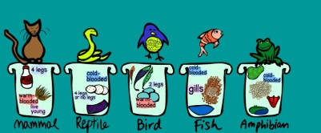

Animal Characteristics Game- 5th Grade Standard 4-5 LS1A Plants and animals can be sorted according to their structures and behaviors.

PLAY NOW

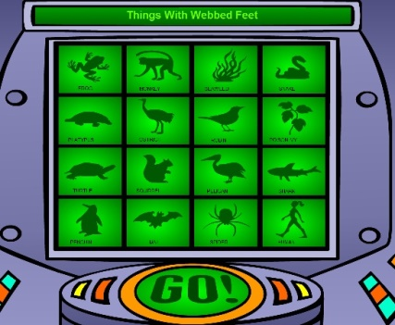
A Touch of Class - 5th Grade Standard 4-5 LS1A Plants and animals can be sorted according to their structures and behaviors.

PLAY NOW

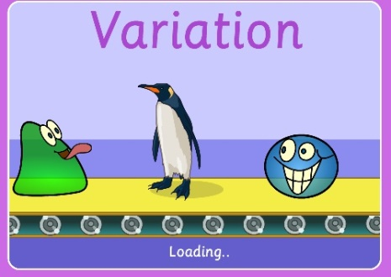

Variation - 5th Grade Standard 4-5 LS1A Plants and animals can be sorted according to their structures and behaviors.
PLAY NOW

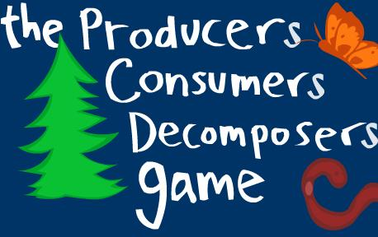
The Producers, Consumers, Decomposers Game- 5th Grade Standard - 4-5 LS2C Plants and animals are related in food webs with producers (plants that make their own food), consumers (animals that eat producers and/or other animals), and decomposers (primarily bacteria and fungi) that break down wastes and dead organisms, and return nutrients to the soil

PLAY NOW

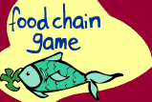

Chain Game - 5th Grade Standard 4-5 LS2C: Plants and animals are related in food webs with producers (plants that make their own food), consumers (animals that eat producers and/or other animals), and decomposers (primarily bacteria and fungi) that break down wastes and dead organisms, and return nutrients to the soil

PLAY NOW

Food Chain Game - 5th Grade Standard 4-5 LS2C: Plants and animals are related in food webs with producers (plants that make their own food), consumers (animals that eat producers and/or other animals), and decomposers (primarily bacteria and fungi) that break down wastes and dead organisms, and return nutrients to the soil

PLAY NOW

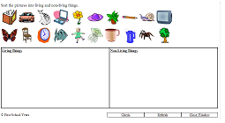

Living Vs. Non Living - 5th Grade Standard 4-5 LS2A An ecosystem includes all of the populations of living organisms and nonliving physical factors in a given area. Living organisms depend on one another and the nonliving physical factors in their ecosystem to help them survive.

PLAY NOW

Food Fight - 5th Grade Standard 4-5 LS2C: Plants and animals are related in food webs with producers (plants that make their own food), consumers (animals that eat producers and/or other animals), and decomposers (primarily bacteria and fungi) that break down wastes and dead organisms, and return nutrients to the soil

PLAY NOW

