Faculty and Staff Instructions to Update MY DATA in Infinite Campus
This can be completed anywhere you have an Internet connection- at school or at home. Allow three business days for processing!!

Background:
The district is using Infinite Campus to communicate to staff in emergencies. This replaces K12 Alerts. It is important that all faculty and staff update and keep current their personal contact information to insure you receive important district and school messages.

Creating/Updating your information:
It is imperative that everyone login to Infinite Campus and update their contact information to insure you received voice, text and /or email notices from the district.
Please follow these steps:
- Go to the Fairfield Public Schools webpage and click on the Infinite Campus link found under the box labeled Faculty and Staff Resources:

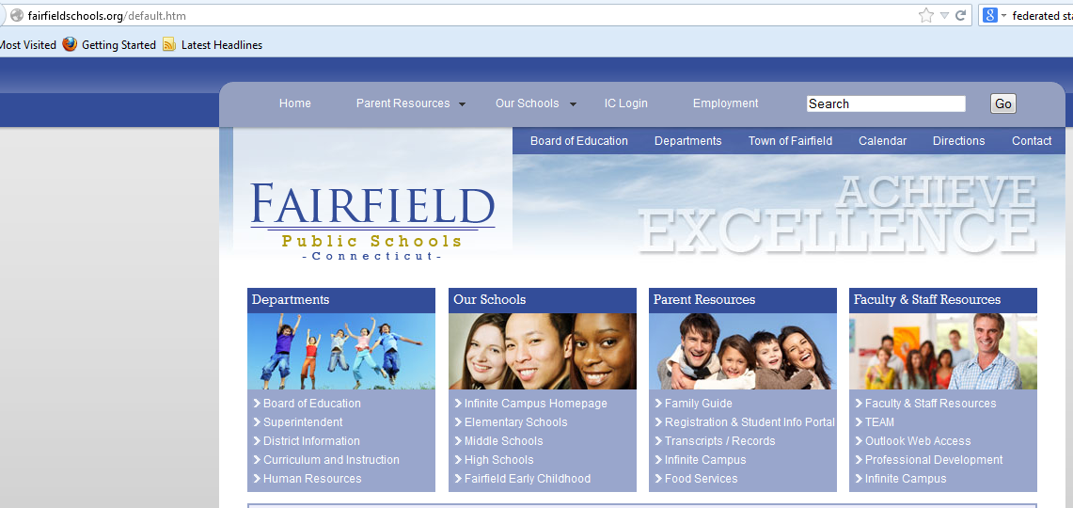

- This will bring you to the Infinite Campus Login Screen:

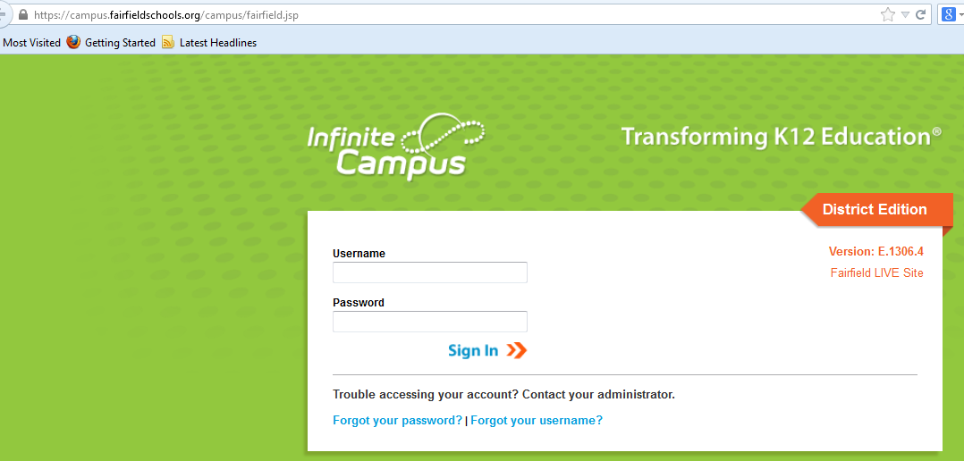

Your Username and Password are the same you use to login to computers at school.
If you have problems logging in, please put in a Kaseya ticket or email reghelp@fairfieldschools.org and one of the IT staff will assist you.

- You will see a screen similar to that pictured below- there will be differences in the list on the left side of the screen depending on your permissions.
- Click on the + sign next to the word “Census” to expand the menu
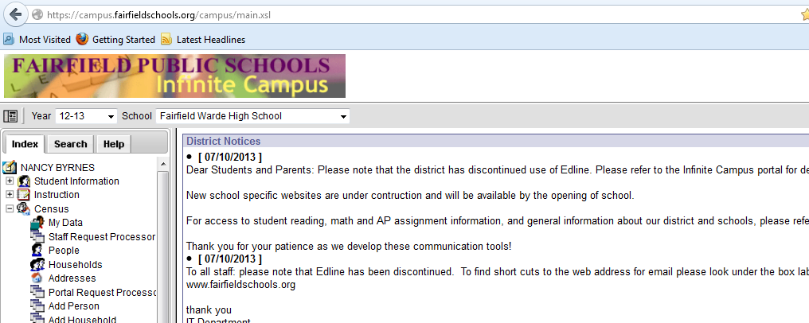
- Click on “My Data”

- A screen similar to the one below will appear with your demographic information. Please click on the Request for Demographic Update to make changes to your contact information.
(You need only include your Gender, and your Personal Contact Information for purposes of district communication. Any other information you wish to include or update is entirely up to you. Please refrain from putting your social security number into the database.)
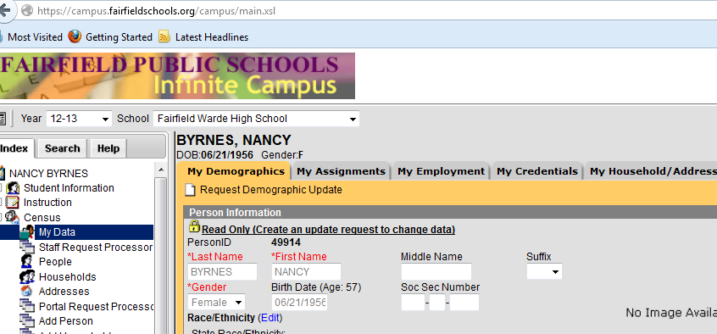

- The screen will change asking you for an update type. Please select “ I am adding or correcting my information”. ( See sample below)
(You may not select to change your legal name through Infinite Campus, that must be done through Human Resources.)
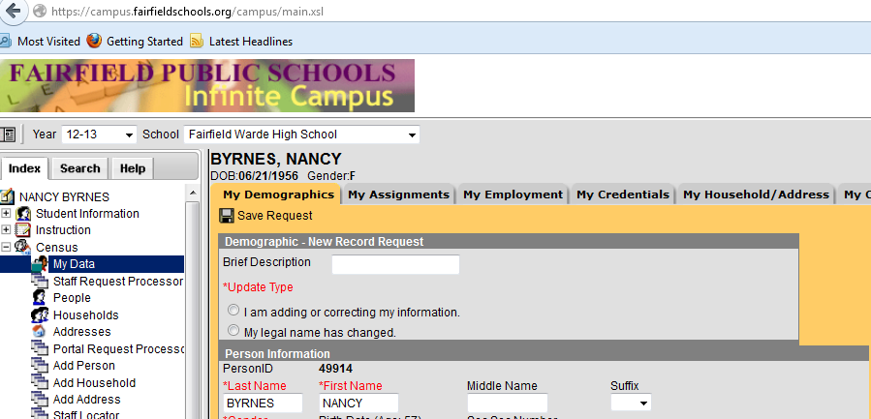
- Scroll Down to the area labeled “Personal Contact Information” 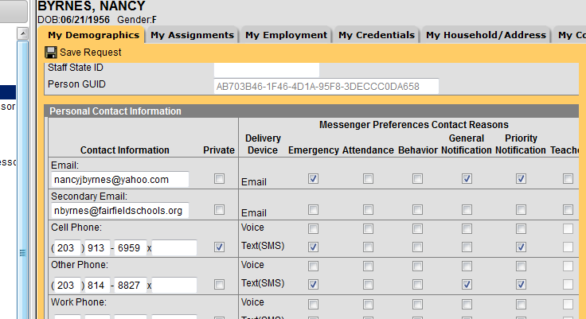
- Complete the email, cell and other phone numbers you wish to be used to contact you in the case of emergency communication.

- Next to the contact information you see the “Messenger Preferences Contact Reasons”. Please insure that you check off the boxes that are under the “Emergency “column. This says that you want to be contacted in that manner if there is an emergency message, such as a snow day or other delay, dismissal or closure.

In the example above (my personal email and cell numbers are redacted to protect my privacy) You can see that I’ve elected to be contacted via my personal email address, and my two cell phones for any emergency message.

You will also note there are other contact preference columns- attendance; behavior and teacher are reserved for those staff members who are parents or guardians of students attending Fairfield schools. As employees, please also check off the communication methods you wish for general notifications (events, newsletters, etc.) and priority notifications which may be notices from your school Principal or important reminders from a central office department).

Save your request by clicking on the “floppy disk” icon
- When you have completed this section, please click on “save request” and your request will be forwarded for review and approval. It will take up to three business days to process your requests, so please plan accordingly. You will get a message in your “process in box” when you request has been approved. Your process inbox is located at the bottom of the splash screen when you first login. To navigate to it, simply click on your name at the top of the Index, and then scroll down to the bottom of the page.
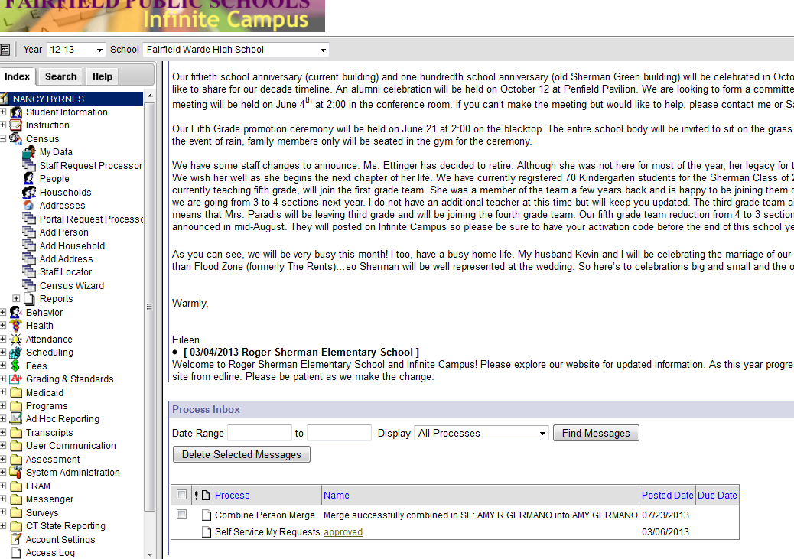

- If you have any questions or concerns, please put a Kaseya ticket in and we will respond.

