Image Formatting

- Insert one image here, resize it so it is about one inch square (insert, picture, then drag corner smaller)

- Put a border on the image and rotate the image. (Format, border - - rotate using green circle)

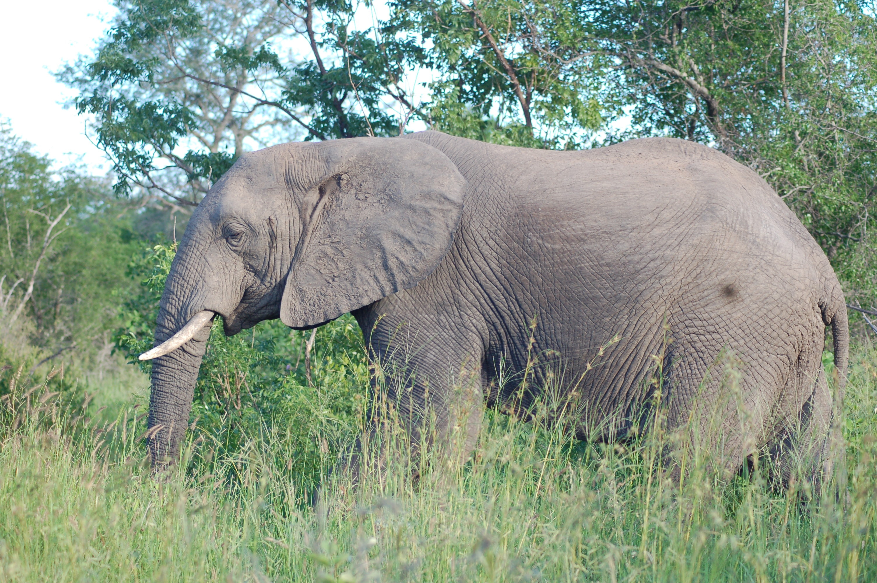
- Change the color of the elephant picture to black and white. (format, recolor)

- Add a red arrow that points to the elephant’s eye. (Insert shape. Then format, outline color)

- Overlap these two images. Make the whole giraffe in front of the head of the giraffe.
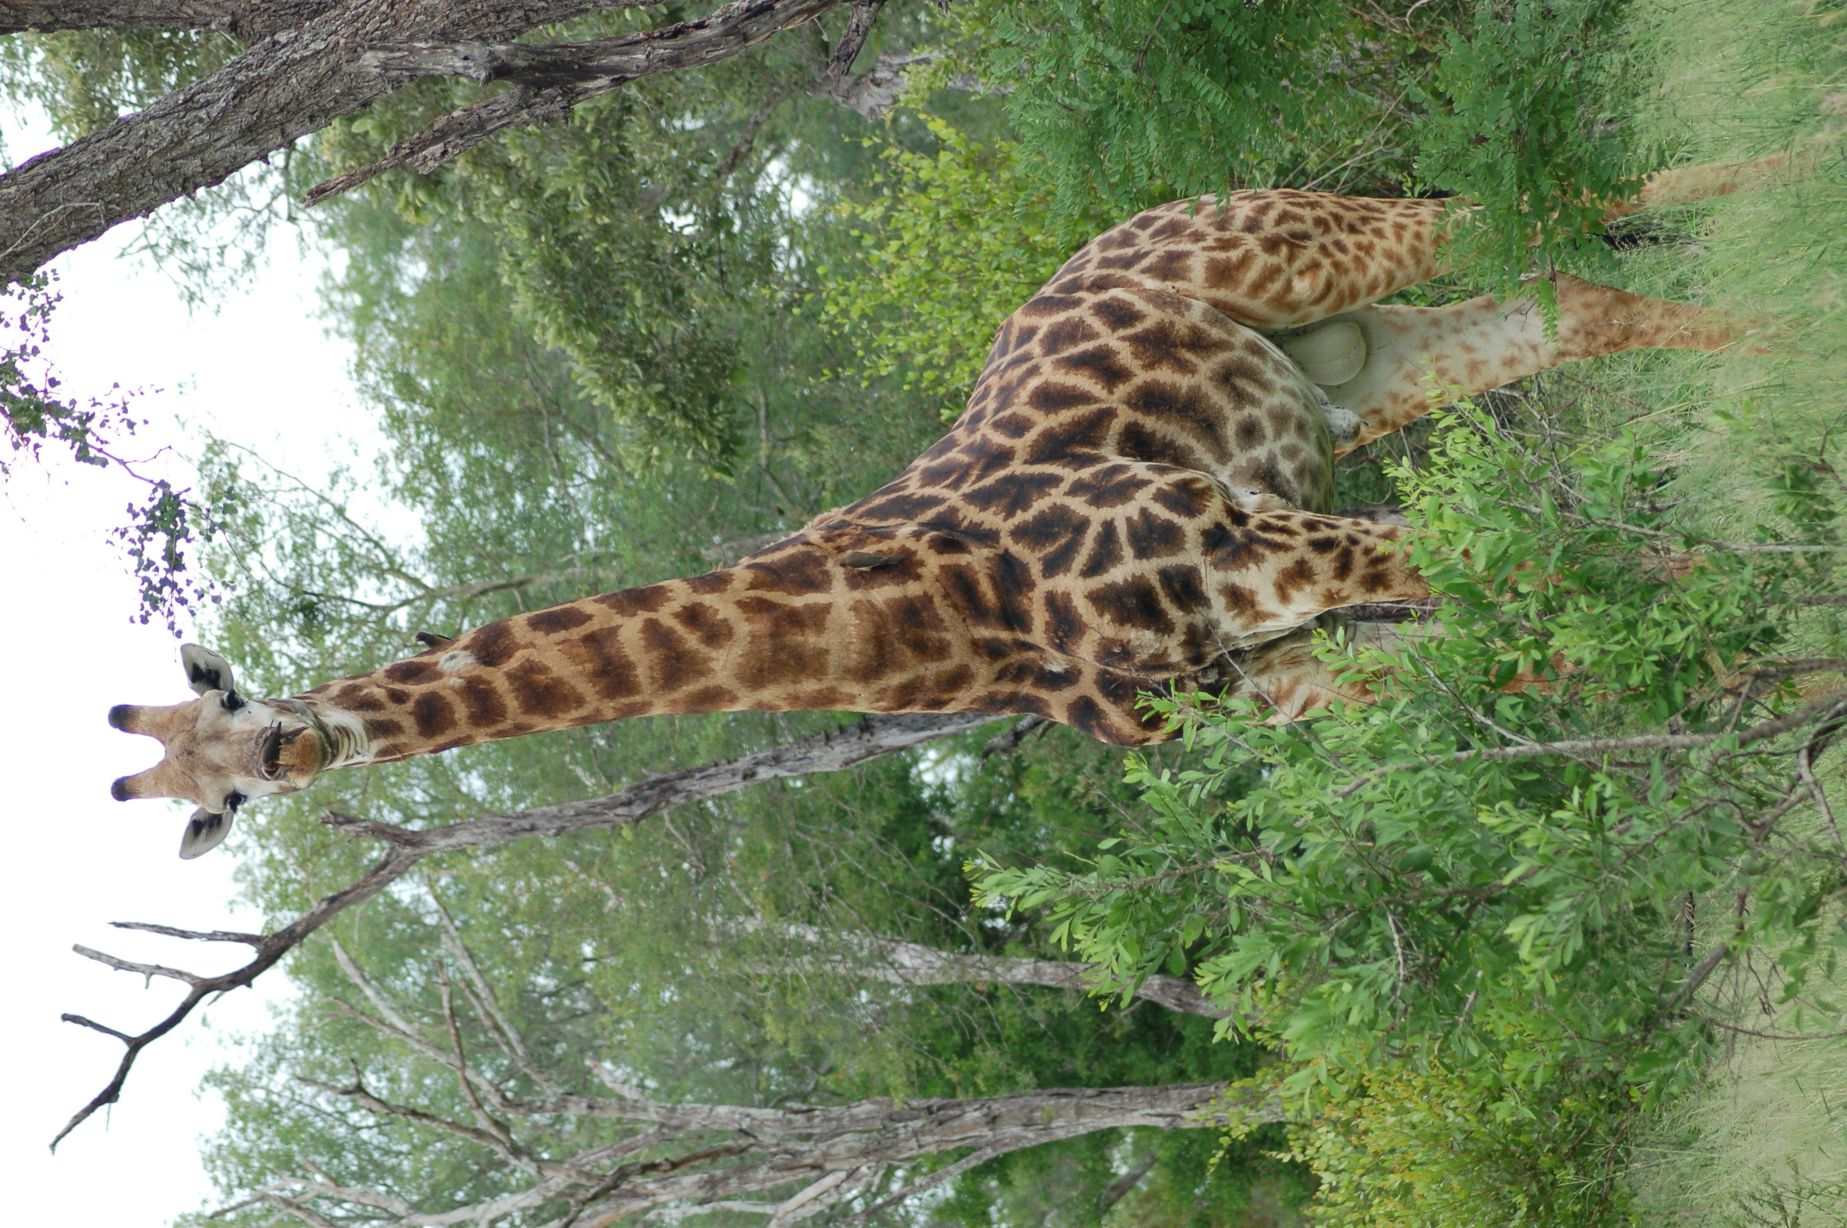
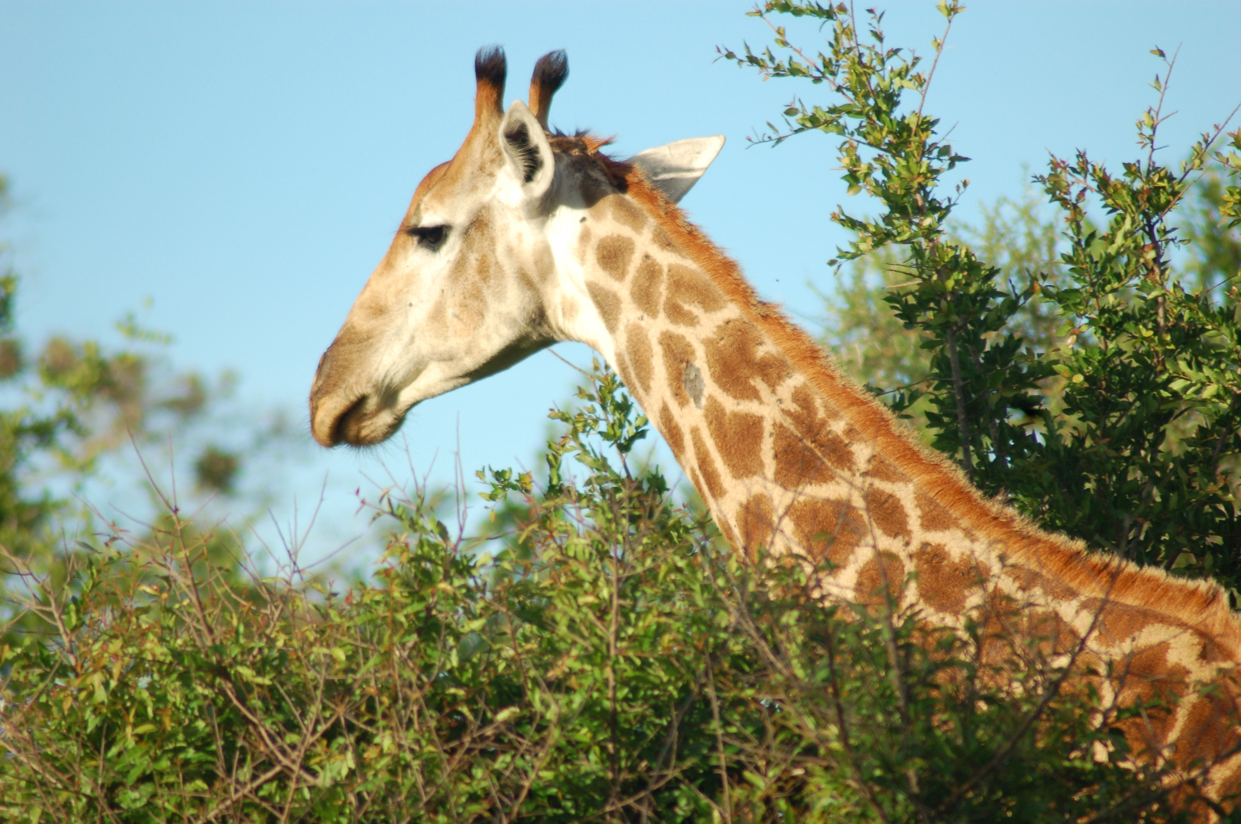

- Crop this picture so you just see the top of the lighthouse (format, crop)


