Making your WordPress Teacher Page
- Add wp/admin at the end of the Sherman URL if the school web page is open and press Enter or click here: http://fairfieldschools.org/schools/sherm/wp/admin
- Log in using the same username and password you use to log on for IC or your school e-mail.
- Click on Teacher Pages on the left panel and then, Add New Teacher Page
- In the future when you want to work on your teacher page, you will click on Edit under your listed page.
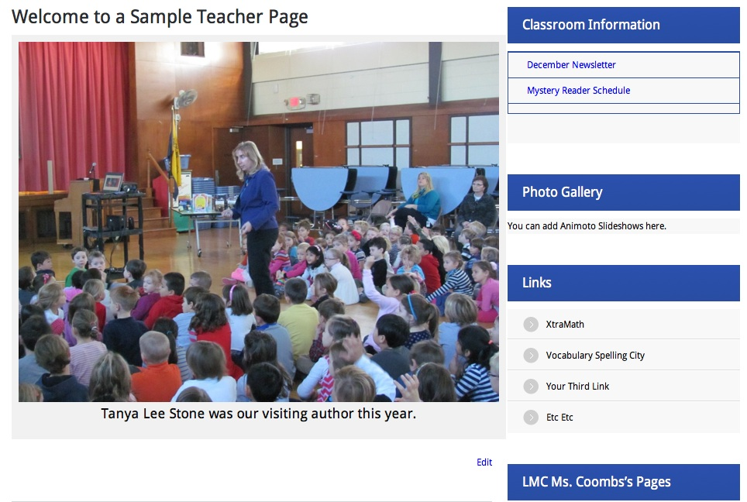
Front-End View – This is the view your parents and students will see.
- You will have a large area on your teacher page where you can add images, text, and or links. On the right side you will see a panel with three additional text boxes. The third one has link placeholders, but you can put links in any of the text boxes and/or remove the placeholders. You do not have to use all the textboxes. You can change the titles to whatever you want, or if you leave the titles and text boxes empty, they will not display.

Back-End Editing
The first box is the largest area of the page, where you can add images, text, and links if it pertains to the text you’re writing. There is a separate links text box at the bottom, which will end up in the right panel.
- You will need to click on the bubble next your name under Categories in the right panel. This will make your page visible on the front end, after you publish your page. If you are not ready to publish it, you can save it as a draft.
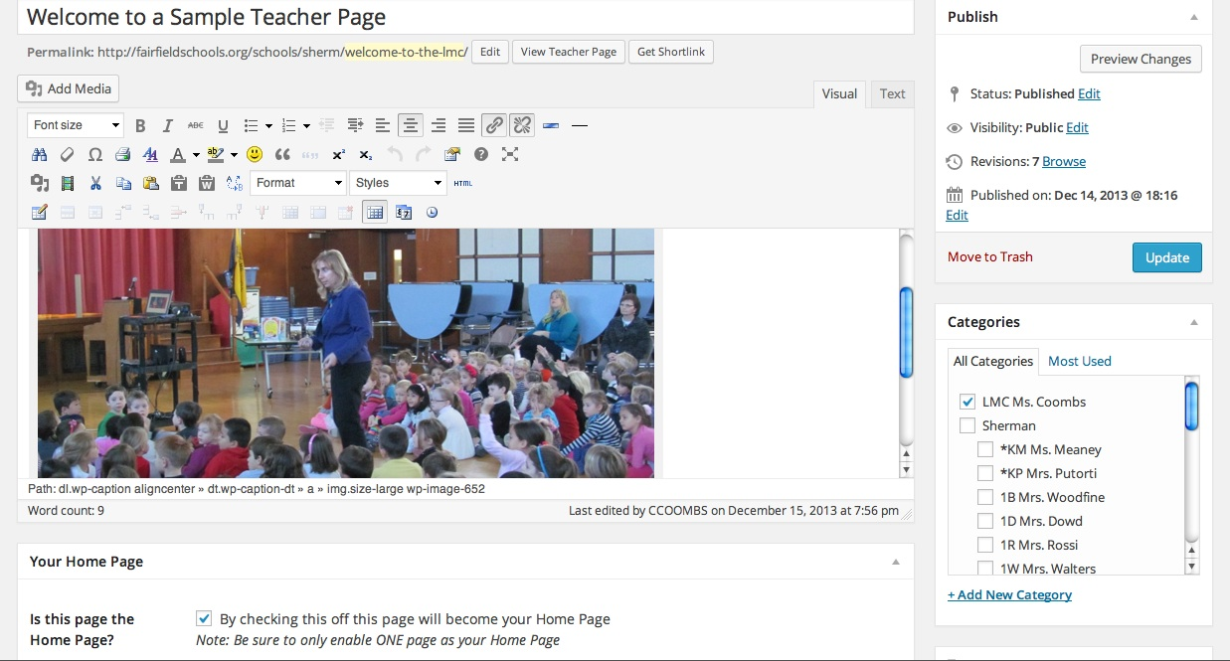
- In addition, click in the box to make this your home page. This will prevent users from having to click on an additional link to access your page. You will find this under the main text box.
- If you want to include a message in this area, you can either use the WordPress formatting tools above the text box to format your text, or you can cut and paste from word.
- If you would like to add an image or a document * you have saved, click on the button, Add Media, above the formatting tools. Make sure you use copyright free images, if you aren’t using your own photos.
* Save your documents as PDF files before uploading them. They will load faster and can be opened on any device. Keep a copy saved as a word document, but then go to Save as again and click on the Format arrows in the middle of the window to select PDF and then Save.

- Click on Upload Files

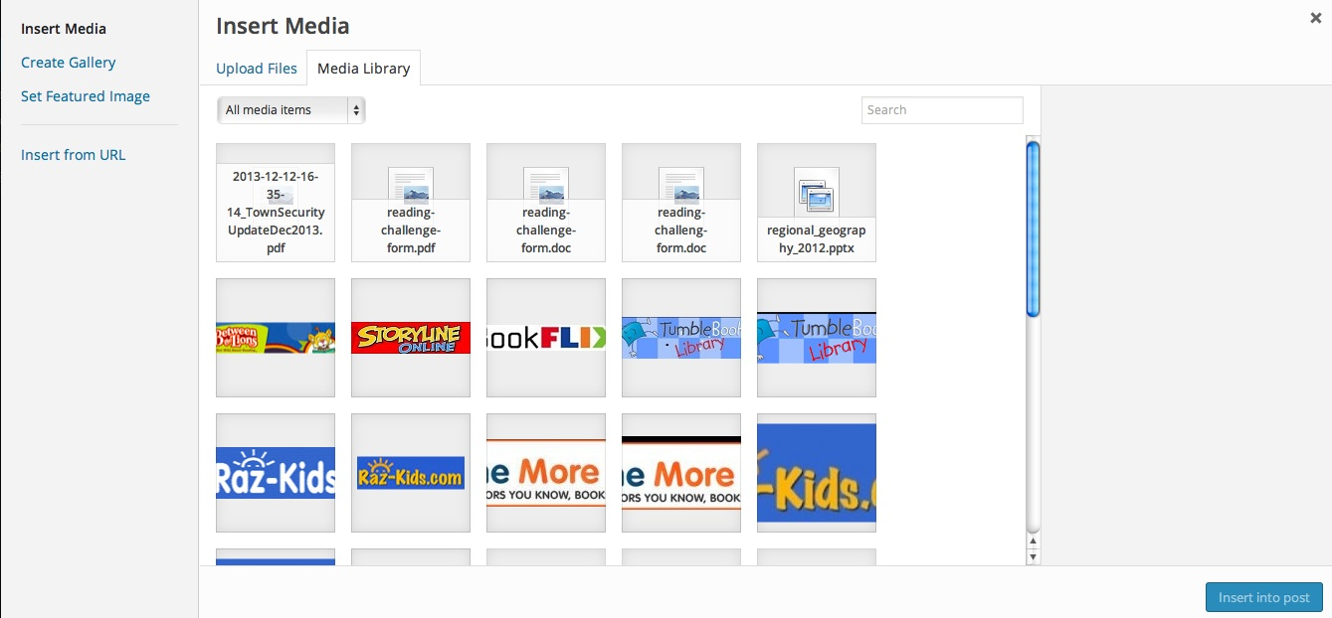

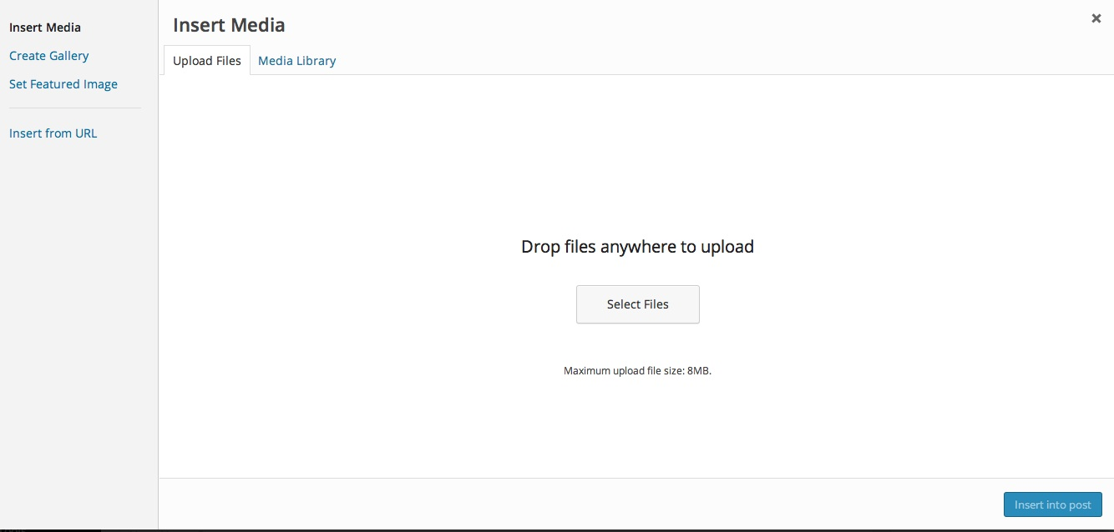
- Select Files

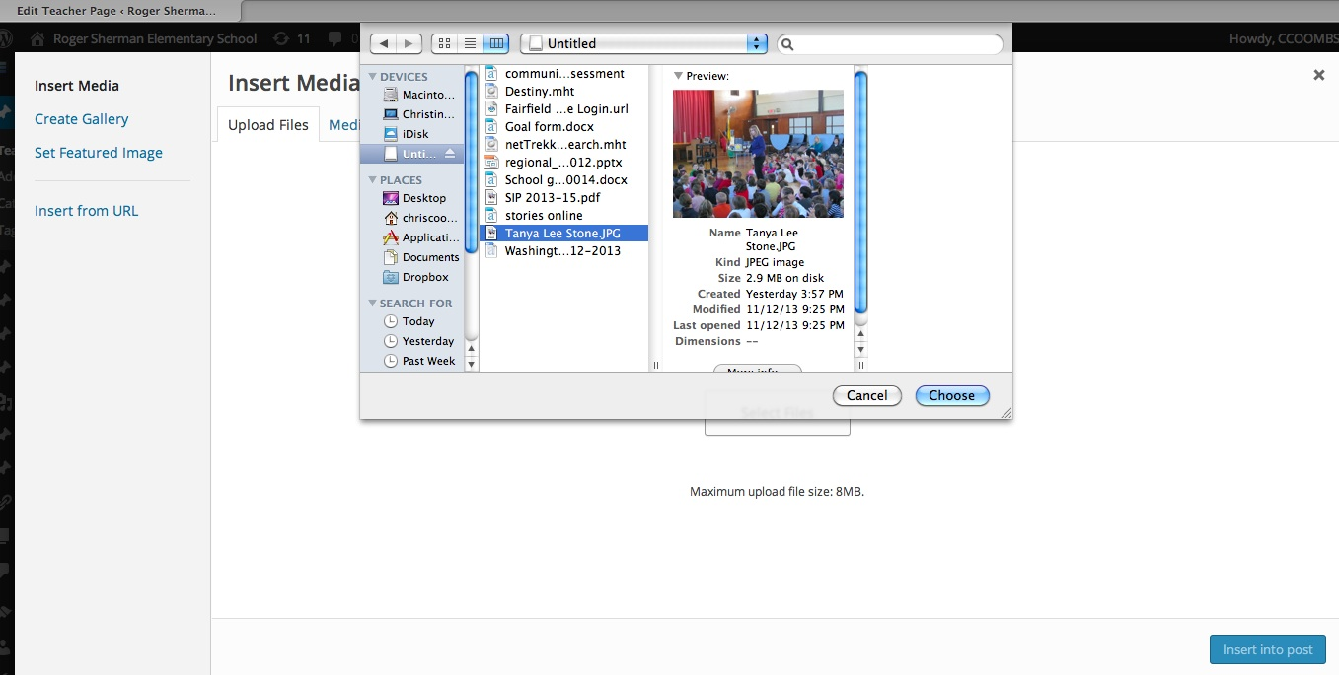
- Navigate to select your file.

Click on the file you want to insert.
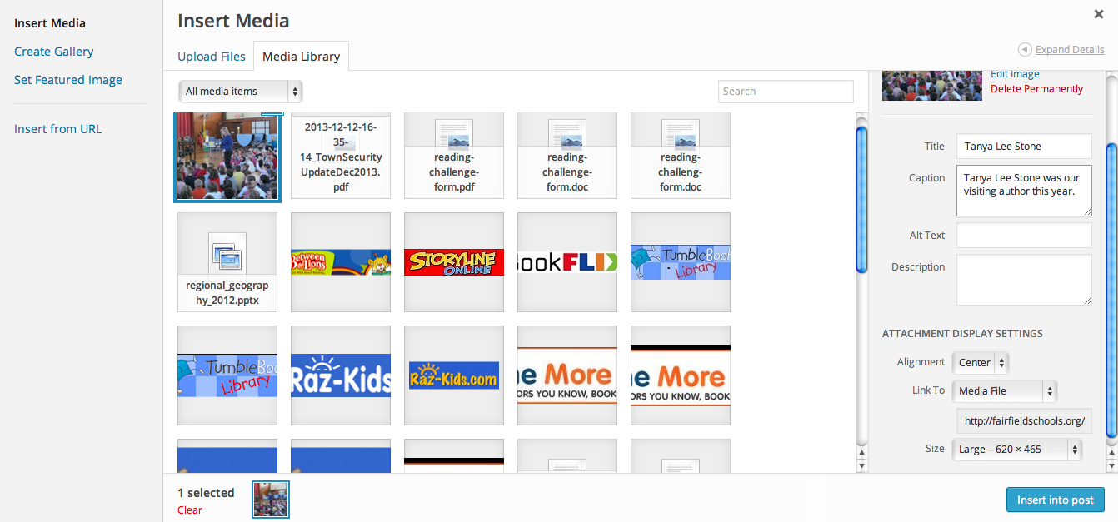
- When inserting a picture, make sure you select the file size and alignment before clicking on the Insert into Post.
- If you would like to include a caption, be sure you do it here.

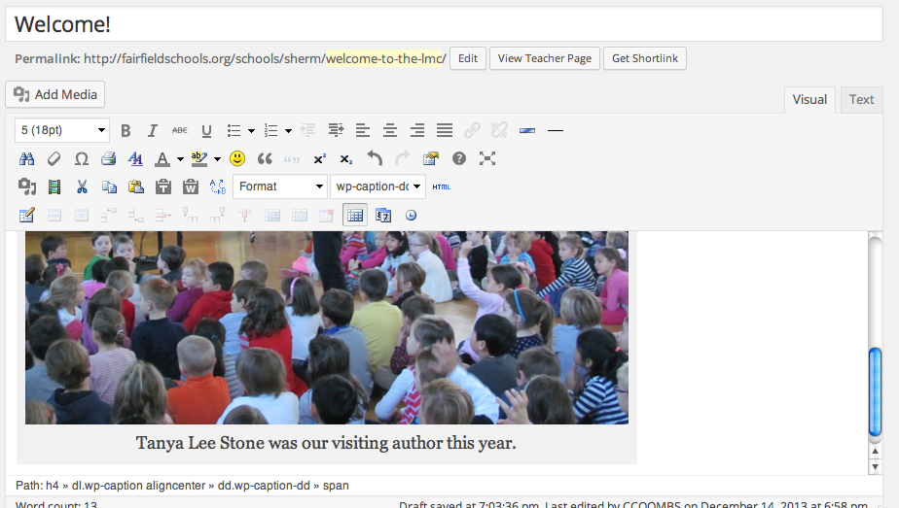
Inserted image with caption:

- You can add more than one image in each text box, but you can also create slideshows using Animoto, inserting the link they provide. PowerPoint slideshows may be too large.

Tables

- You can use a table to keep documents and links listed in a column, under a text box. If you don’t use a table, links and uploaded files will end up side-by-side in the same line on the front end.

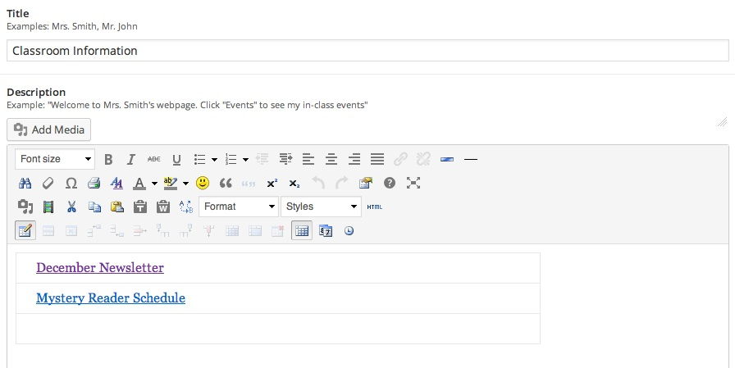
- This is the Insert a New Table button. It will allow you to select the number of columns and rows you need.
- You can delete or add cells in the future with buttons that will appear to the right of this button when you click on cells. You can also add a background color to your table.

Text Box Dedicated to Links
Follow these directions rather than the directions the Webmaster included on the editing page.
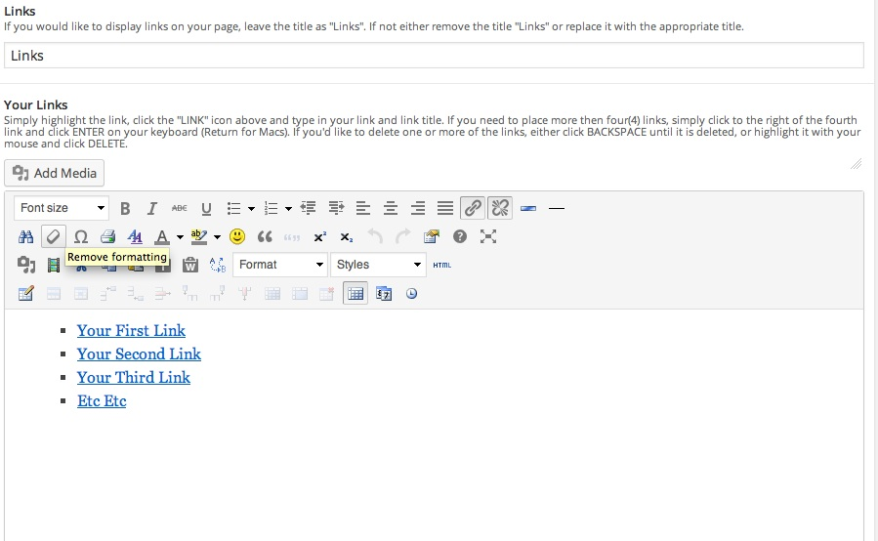
- Select a link place marker and change the text to the name of the website to which you will be linking.
- Then click on the link icon.
- Type in the URL.
- You do not need to type the title. It doesn’t work if you type it here, but not on the page.
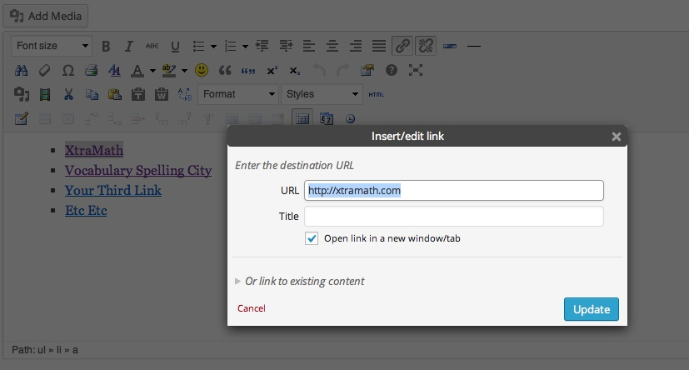
- Be sure you click on Open Link in a new window/tab before clicking on Update.

