HOW TO ADD (OR REMOVE) A NETWORK PRINTER ON WINDOWS 7 MACHINE
Go to the lower left corner and click on the START button 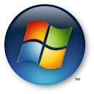 Go up to the empty field where the spy glass is. Type in \\nsvm

Click ENTER.

A window will come up, listing all the network printers in your building. (the example below is from Burr. Find the printer for your classroom.
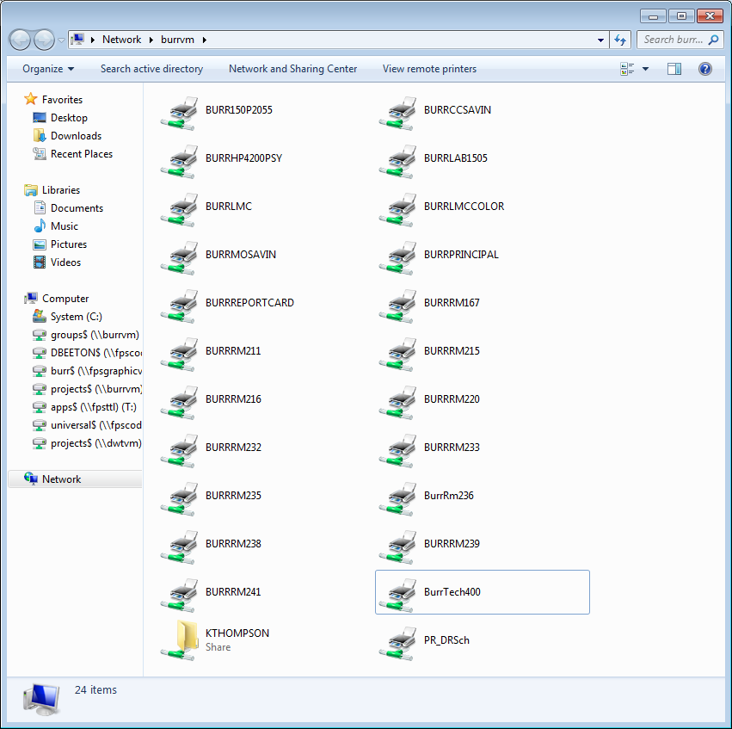

Double-click on the one you’re looking for. Wait a little, and a little window will open, showing that you’re connected.
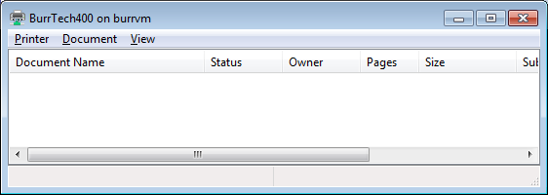
Close the window. Continue doing that until you have chosen all the printers you want.
Now go to the START button again, then over to the right to Devices and Printers. A window will open showing all the printers you have chosen above, plus some other things you might have attached to your computer.
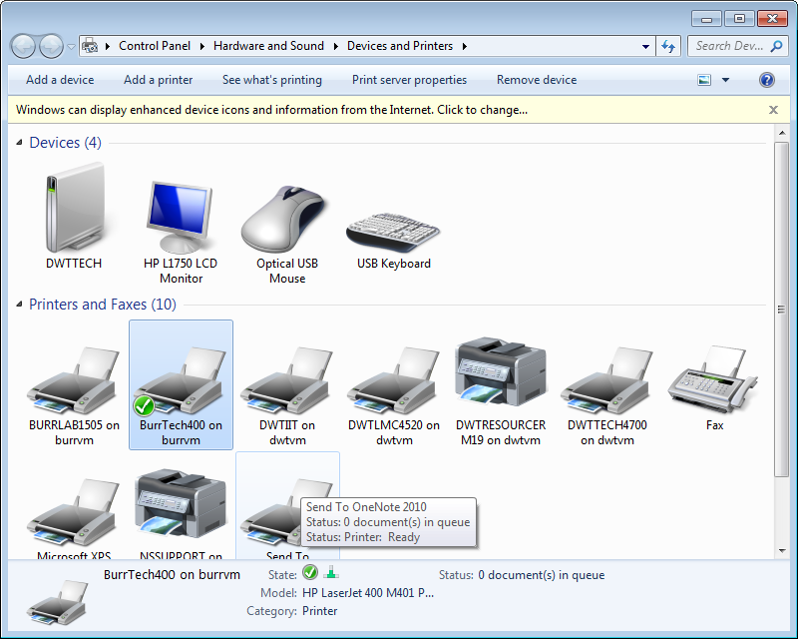

In order to make one of these printers your DEFAULT printer, right-click on the printer and go down to “Set as default printer.” A green check mark will appear on that printer’s icon.
Likewise, if you need to remove a printer, you right-click on the printer and go down to Remove Device.

