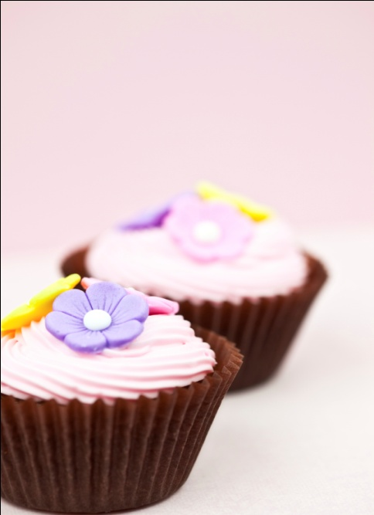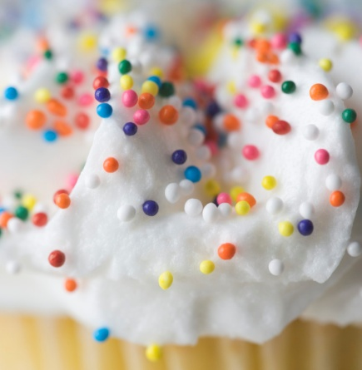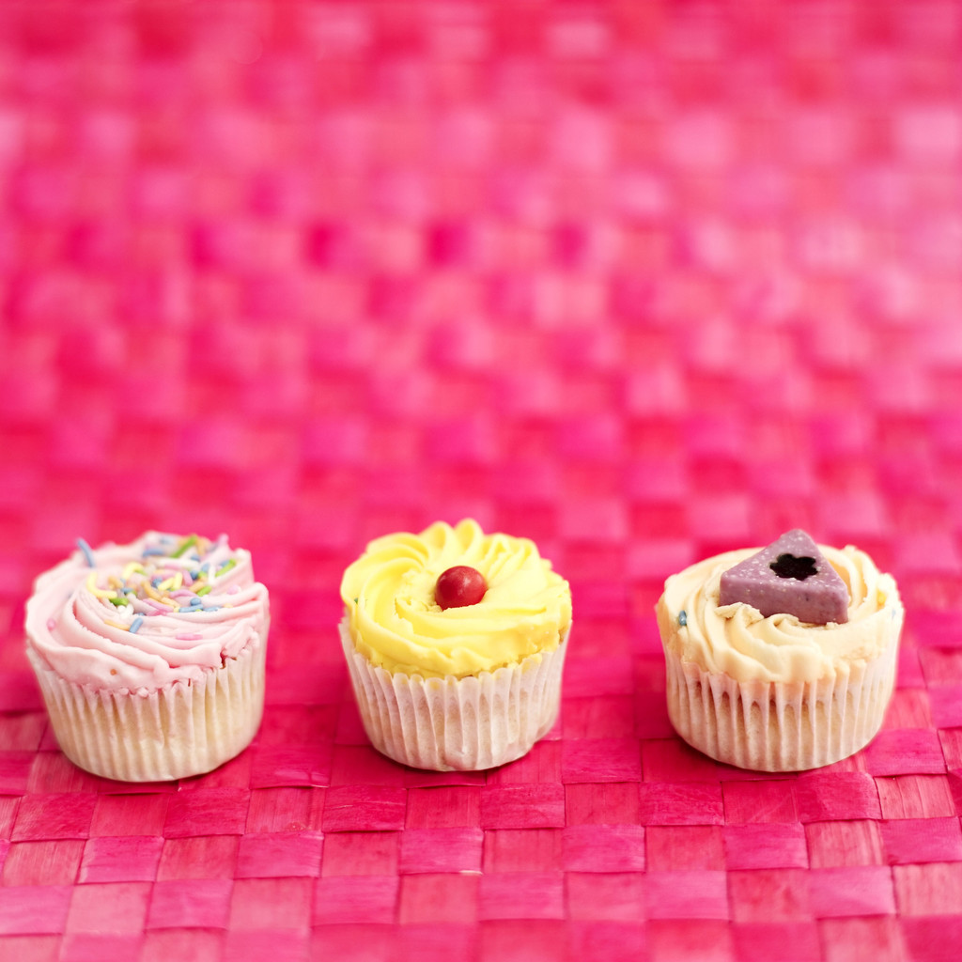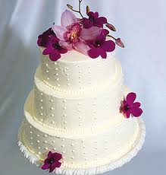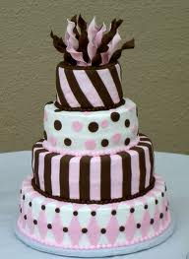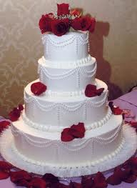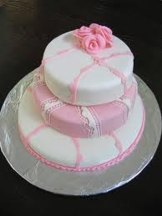

**Were- central park!**

**When- all day till sunset were we will be doing design your own cakes, were you design your cake and we make it for you!**

**Serving- we will be serving are finest cakes and treats/cup cakes!**

Treats are sweet!!!

Grand opening!

A DAY WITH OUT CAKES IS A DAY WITH OUT FUN!

Do you have a sweet tooth?