

**March 10, 2012**

**Dodgers vs Canada**



**2012 World Baseball Classic**

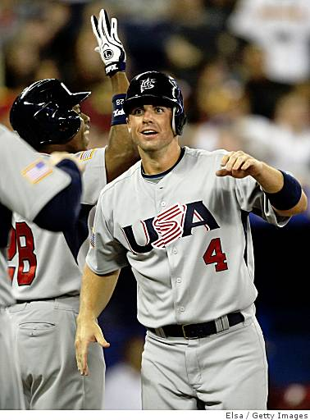

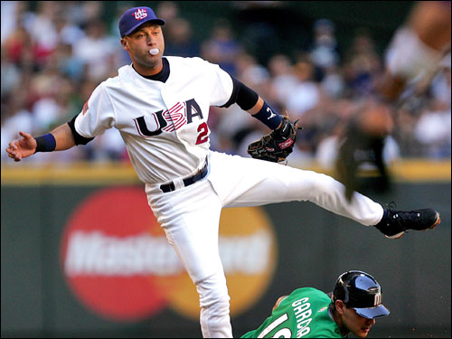

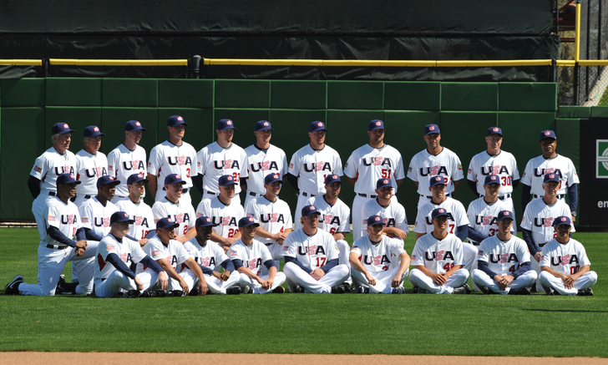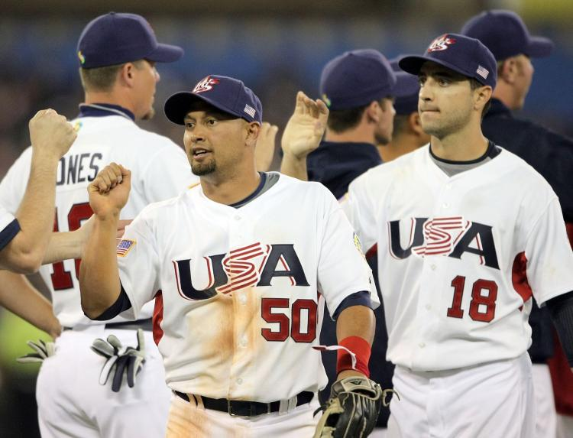

**Come watch the U.S. win the pennant this year!**

**Come watch All-Stars like Ryan Braun, Shane Victorino, Chipper Jones, and Kaz** Matsui!

**Come see David Wright and Derek Jeter team up**