Dairyland, Wisconsin

Dairyland, Wisconsin

2:002:00 P.M

C:\Users\omansour\AppData\Local\Microsoft\Windows\Temporary Internet Files\Content.IE5\9UXLKB5I\MC900052811[1].wmf

Pretty, happy, and cute cows!

These cows can all be judged on your scale from one to ten!

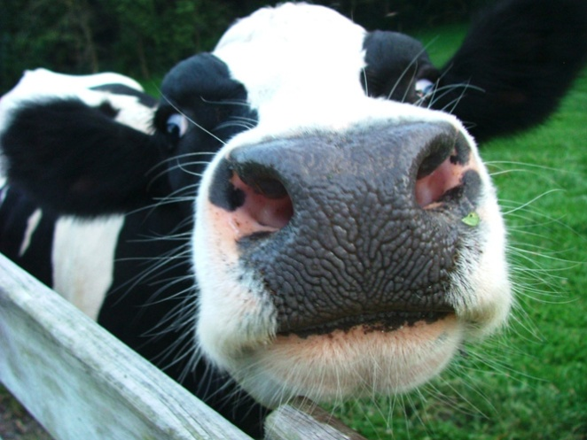

C:\Users\omansour\AppData\Local\Microsoft\Windows\Temporary Internet Files\Content.IE5\9UXLKB5I\MC900052811[1].wmf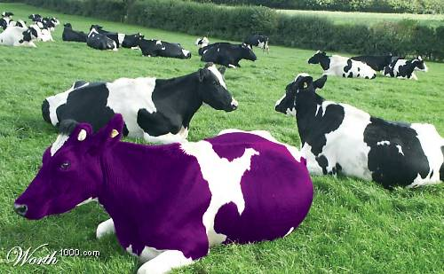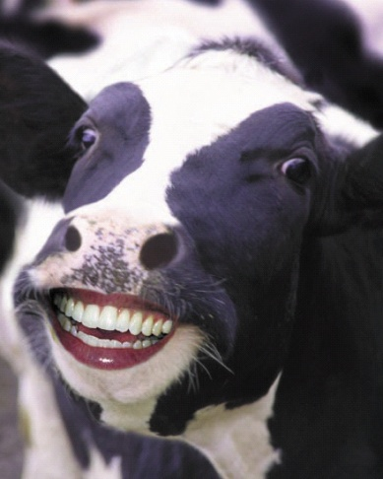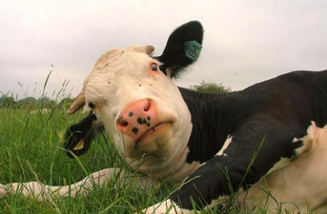C:\Users\omansour\AppData\Local\Microsoft\Windows\Temporary Internet Files\Content.IE5\9UXLKB5I\MC900052811[1].wmf

Even the most beautiful of cows!

We have exotic cows imported from all over the world!