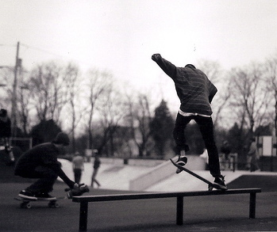

At Jennings Skate park in Fairfield, CT

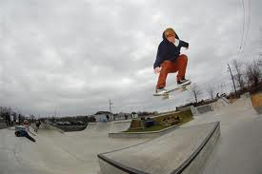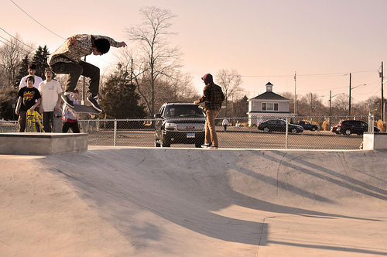

April 14th at 12:00pm to 2:00pm. Anyone can enter 12 and up. 21 and up after party.



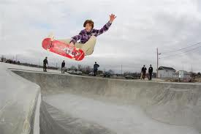[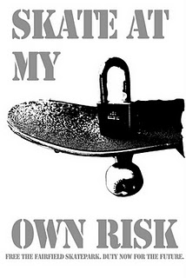](http://www.facebook.com/pages/Keep-Jennings-Beach-Skatepark-Free-and-Open/121323684588251?ref=mf)

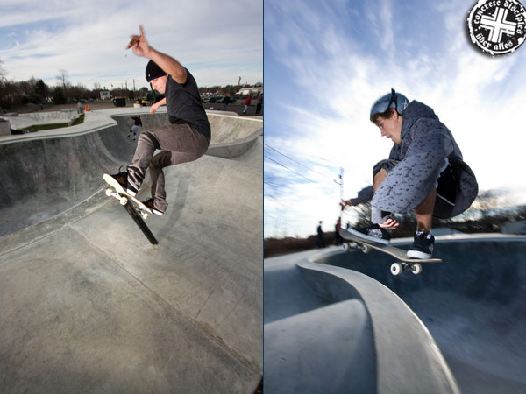

Sponsored by: