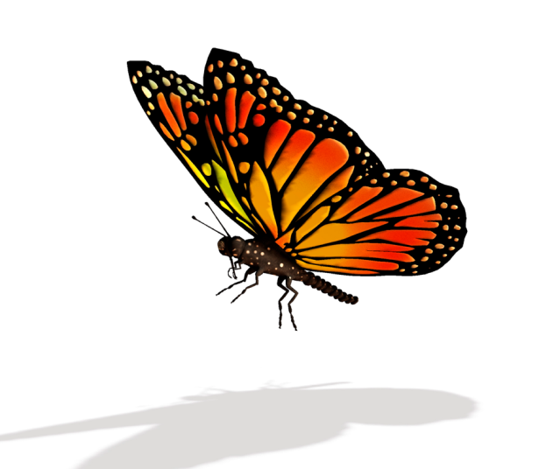

Monarchs are in trouble!
http://www.learner.org/jnorth/images/graphics/mexico/PopulationEstimate.gif
http://www.nytimes.com/2013/11/24/sunday-review/the-year-the-monarch-didnt-appear.html?_r=0
To learn more about the life cycle of the monarch butterfly: http://www.learner.org/jnorth/tm/monarch/jr/KidsJourneyNorth.html
Compare the maps of monarch sightings and the first sightings of milkweed. What do you notice?
http://www.learner.org/jnorth/maps/Maps.html

