Would your child enjoy practicing their keyboarding skills from home?

Fairfield Public Schools use the Type-To-Learn 4 software in our elementary schools to teach and reinforce keyboarding skills. As parents in our school, you are able to download this software if you would like your child to use it at home. It will run on both PCs and Macs.

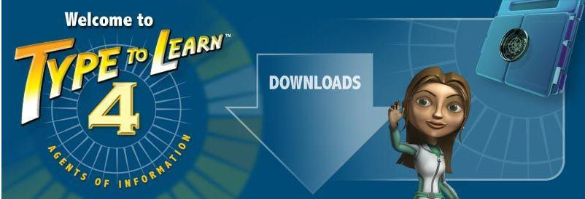

▪ If you wish to download the software please click on the link below.
▪ You will need to scroll to the bottom of the page and use the FULL VERSION
downloads. (or click on Full Versions under Student Use at Home Procedures)

▪Please be aware that the download can take up to 2G on your home hard drive!

▪ After downloading and installing your child will be able to log-in to TTL4 using the same user name and password they have been using at school.
▪ The first time your child does this from home they will need to type in the
account code #126636. They will only have to do this the first time.

Link to download the program:

http://ttl4.sunburst.com/downloads/

Full version downloads are at the bottom of the page.

Questions?
Feel free to email Denise Rehder at drehder@fairfieldschools.org

