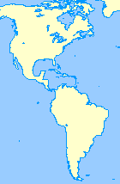C:\Documents and Settings\drehder\Local Settings\Temporary Internet Files\Content.IE5\5Q8A8DGC\MC900250718[1].wmfC:\Documents and Settings\drehder\Local Settings\Temporary Internet Files\Content.IE5\7B5V9PV5\MC900150095[1].wmfExplorer Sites

Data Base of Explorers from an elementary school in Tennessee: Check your dates here. <http://mce.k12tn.net/explorers/explorers.htm>

Short biographies s from EBSCO host: Leif Ericson, John Cabot, Henry Hudson, Christopher Columbus, and Ponce de Leon <http://www.ebscohost.com/flashPromo/historyhappenings/explorers.html>

**Marco Polo's Journey** <http://edsitement.neh.gov/M_Polo_flash_page.asp> An interactive map of his journey.

**Tudor Exploration** <http://www.nmm.ac.uk/TudorExploration/NMMFLASH/index.htm> An interactive look at why people chose to explore, the tools they used, what their boats were like and other interesting information.

Once you have researched your explorer, check out this web site to see if you agree with the writer about why your explorer should be remembered: <http://library.thinkquest.org/J002678F/>

Follow the routes of these explorers: De Soto, Magellan, Cook, Columbus, Pizarro, Hudson, the Search for the Northwest Passage, Marco Polo <http://awesome.good.is/features/011/Wanderlust/index.html>

The most detailed map of De Soto’s last journey: <http://floridahistory.com/inset78m.html>

An Explorer site you won’t want to miss! <http://www.allaboutexplorers.com/explorers>

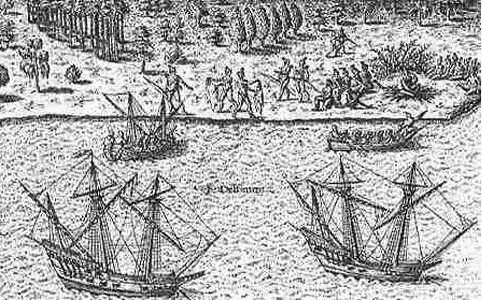Read carefully – not all web sites are accurate!